Malware Analysis Project:

The malware Analysis process comes in many different stages:

1. Virtualization Phase
2. Malware collection Phase
3. Static malware analysis Phase
4. Dynamic malware analysis Phase
5. Conclusion and recommendation

1-Virtualization Phase:

Firstly, in order to provide a virtualization environment, we installed Oracle Virtualbox since VMware workstation 16 player version does not provide the ability to take snapshot (which is a base point to retrieve the VM to it after dissecting the malware). And all security has been disabled such as software antivirus as well as the firewall.

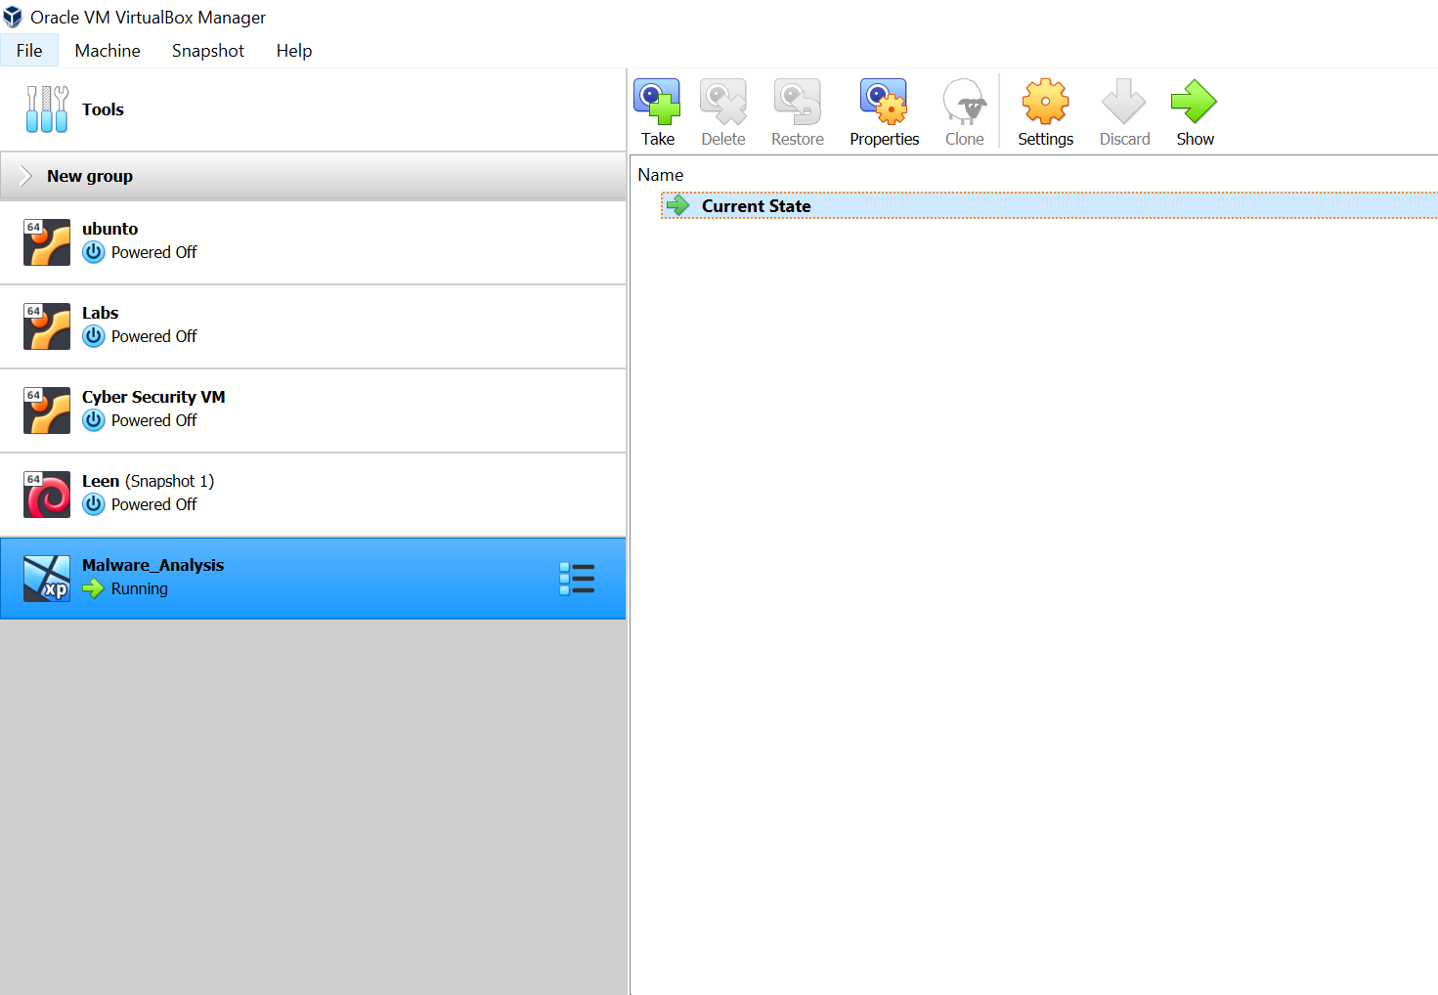

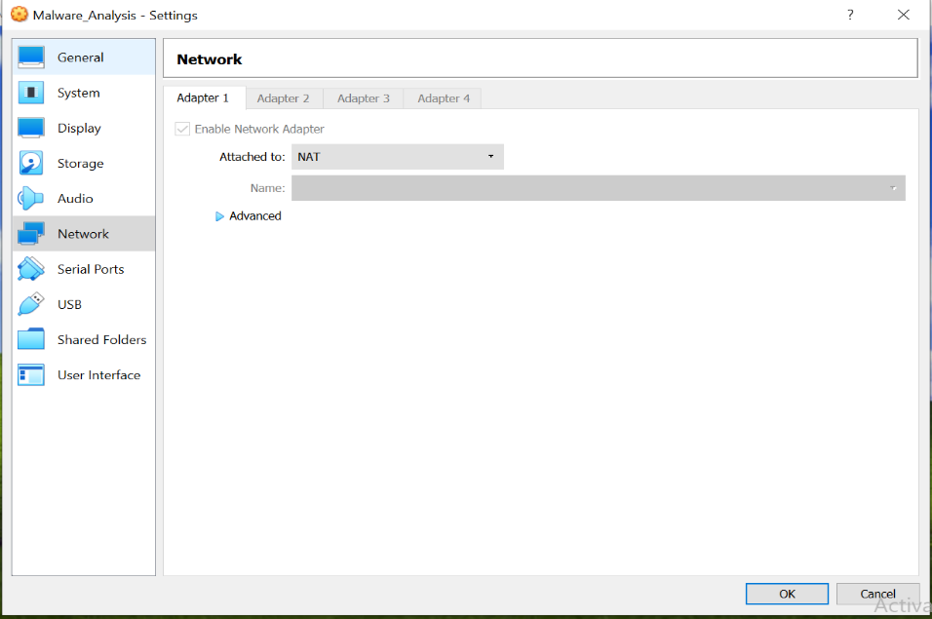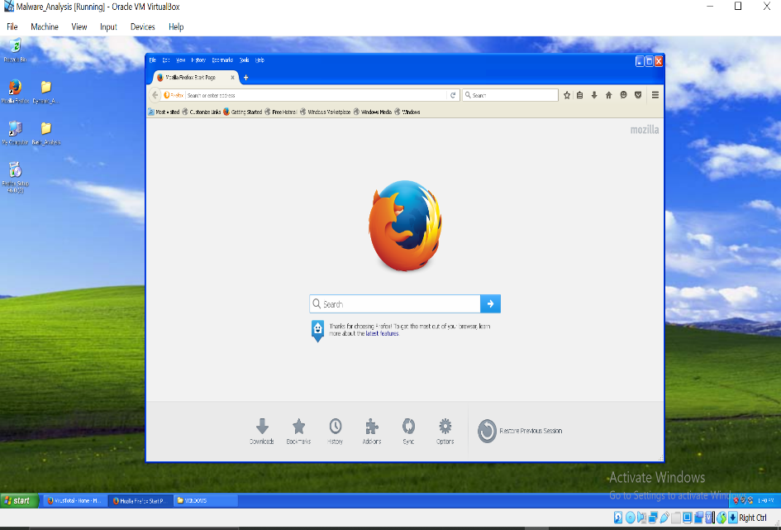

We will use NAT network option that allow the vm to see other vms and the internet but set a router between LAN and the vm

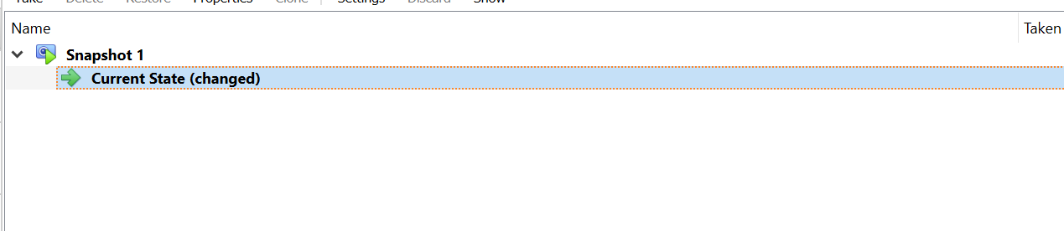Create Snapshot to return to after finishing the analysis.

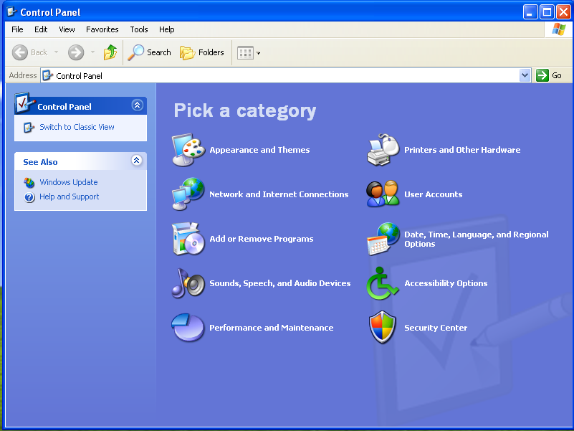

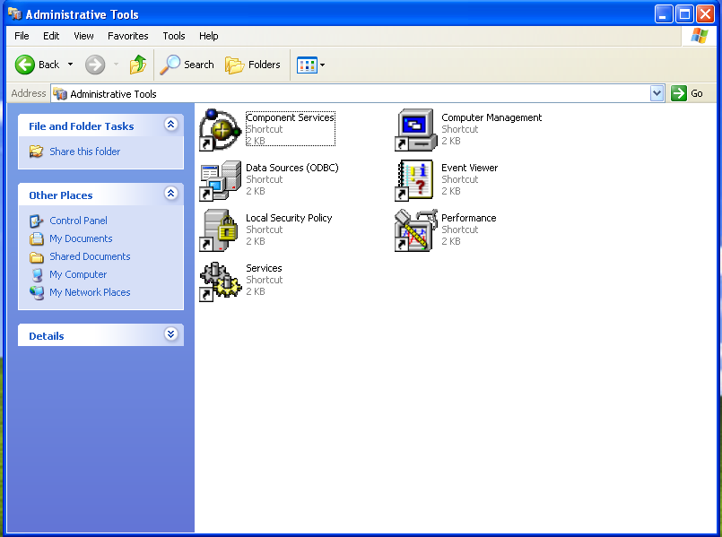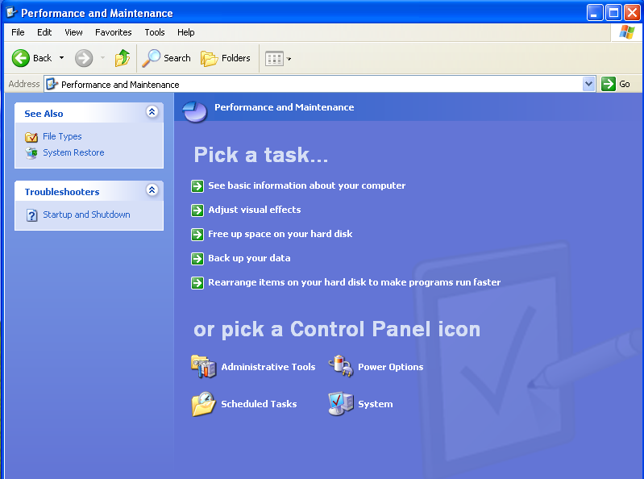

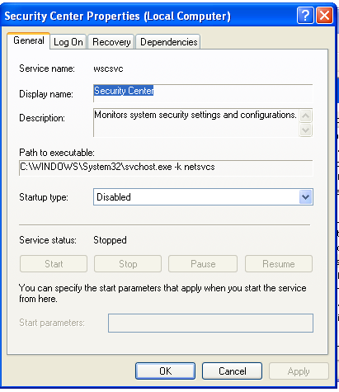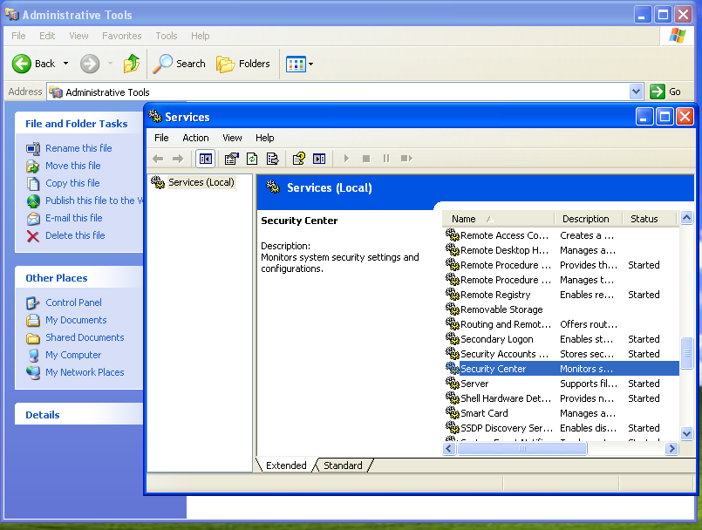

2-Malware collection Phase:

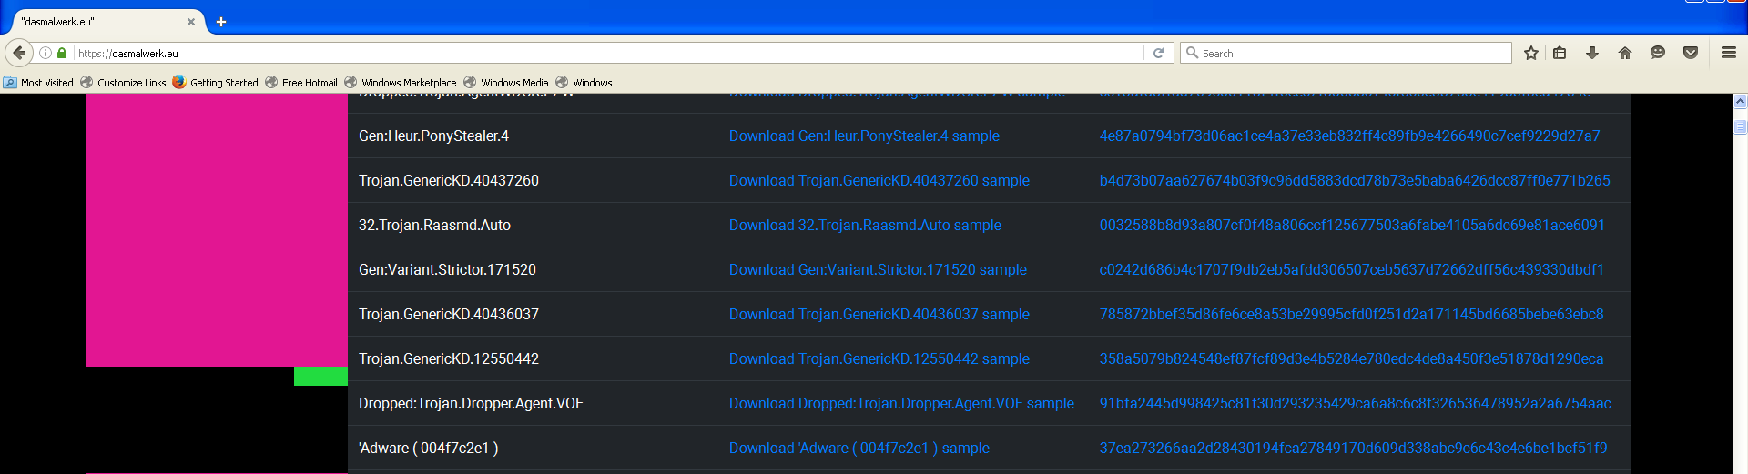We got the Malware from that provides a database of malwares **https://cyberlab.pacific.edu/resources/malware-samples-for-students**



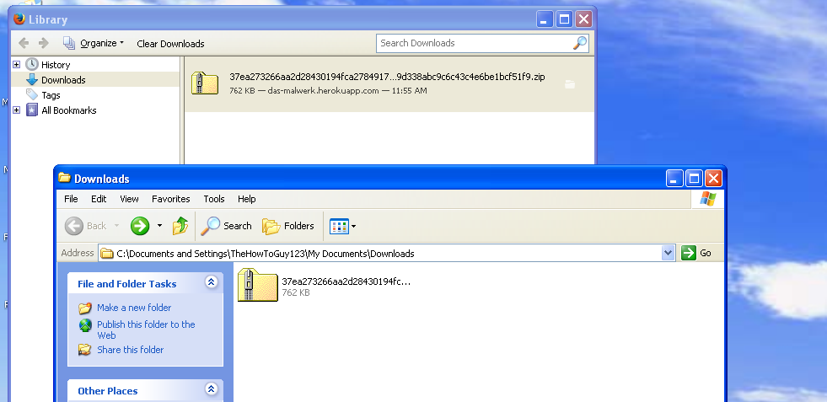

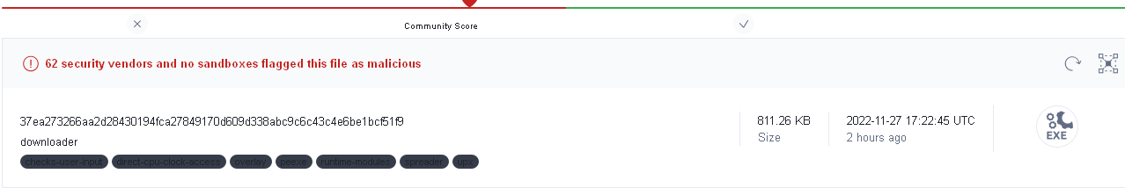The below screenshot shows the downloader malware which is an executable malware that attempts to gain access to the internet to download additional malwares.



3-Basic Static Analysis

**A-VirusTotal:** it’s a web-based tool that provides scanning the suspicious file among different

Antiviruses scanners.

We can upload file, URL or hash of the file (That we can provided online or by tools).

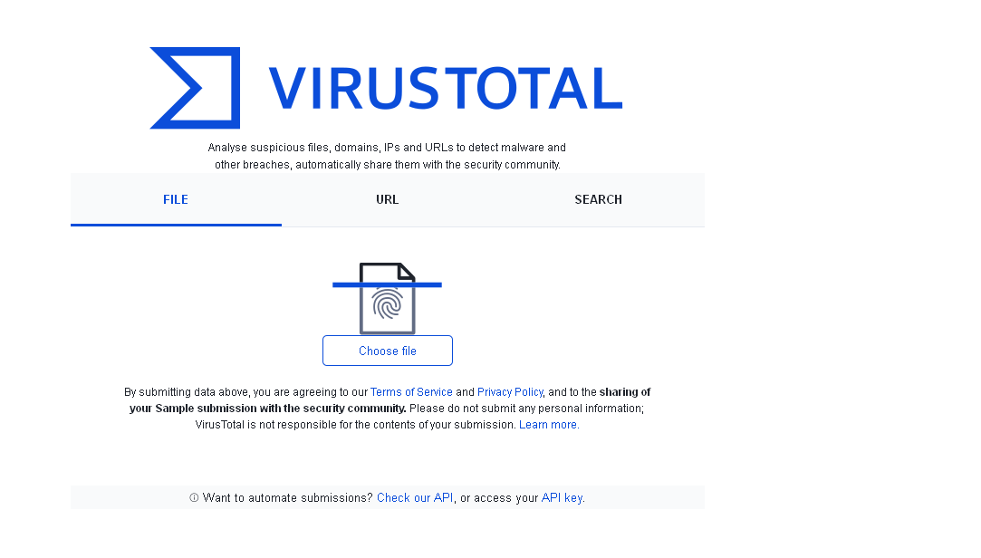The malware have been marked as a suspected file by 62/72 anti-virus engines.

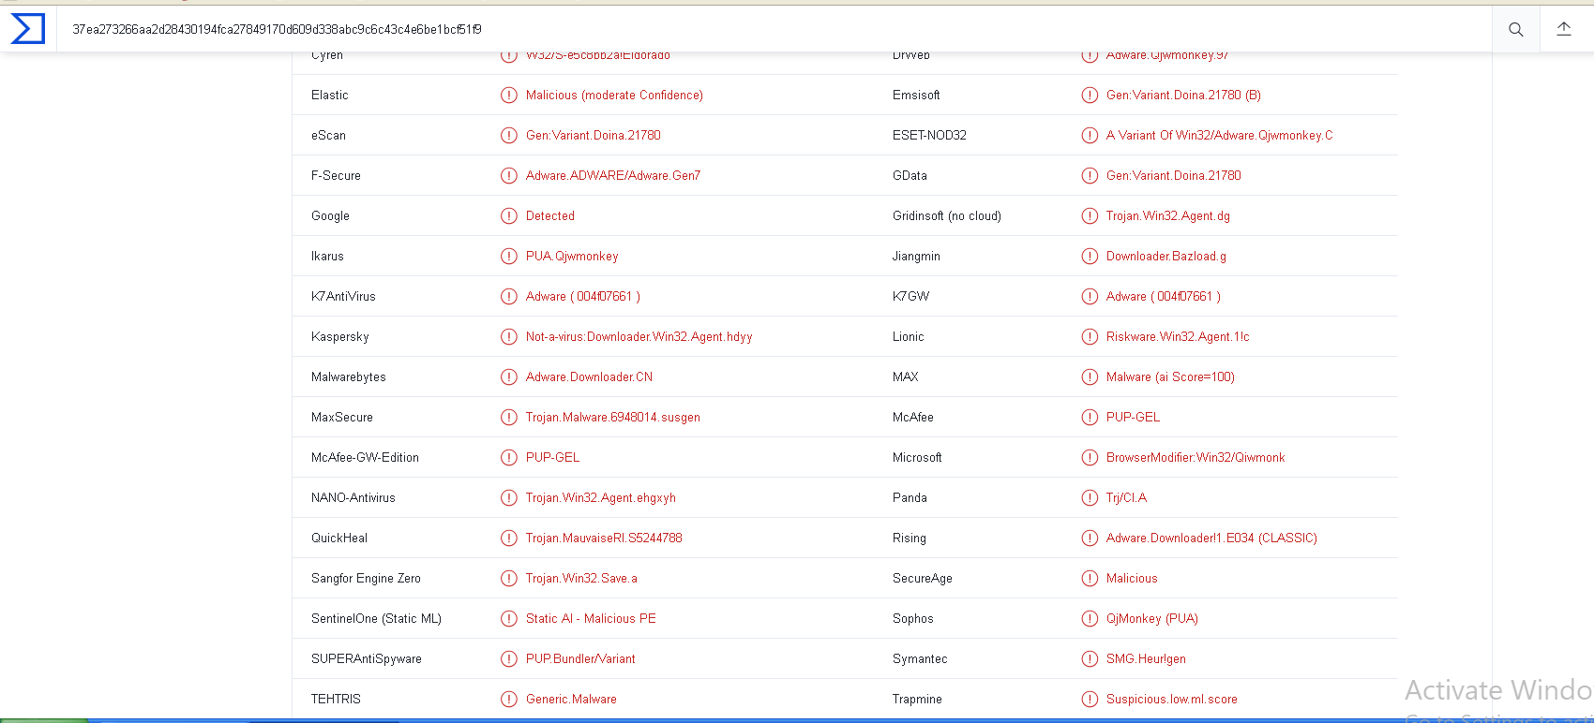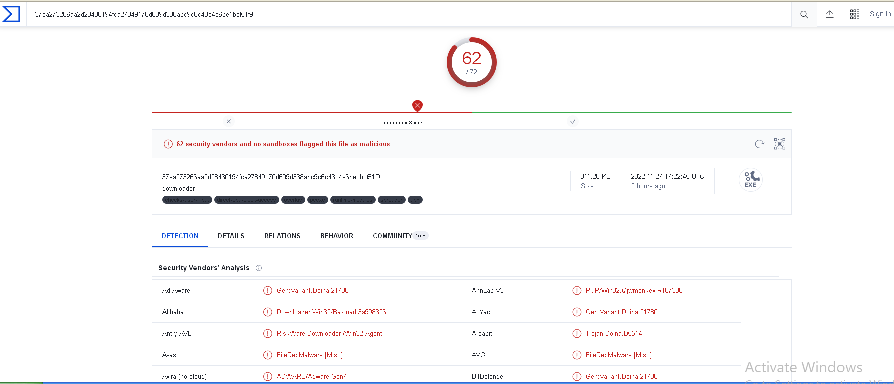

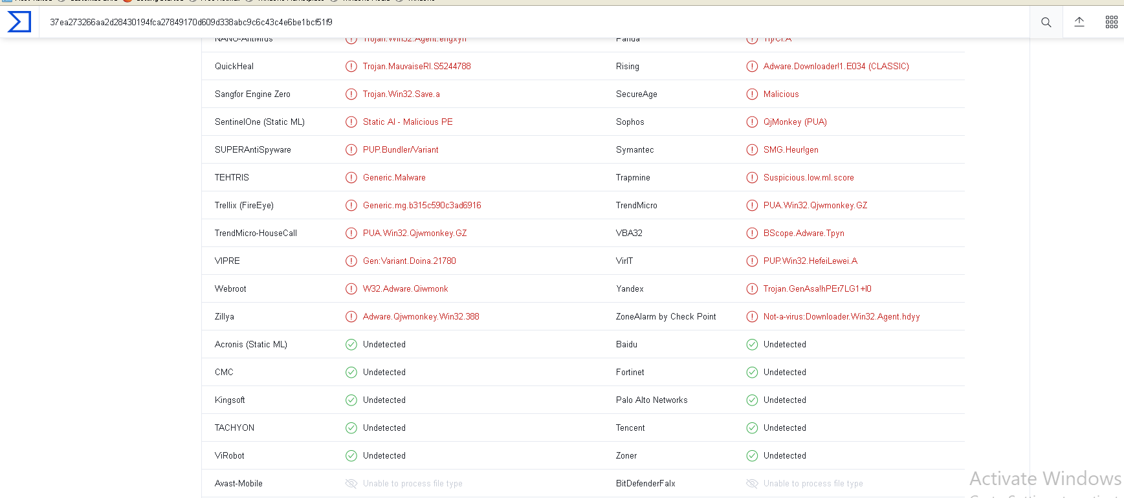

B-**MetaDefender Endpoint:** File-based vulnerability assessment technology scans and analyzes binaries and installers to detect known application vulnerabilities before they run on endpoint devices, including IoT devices.

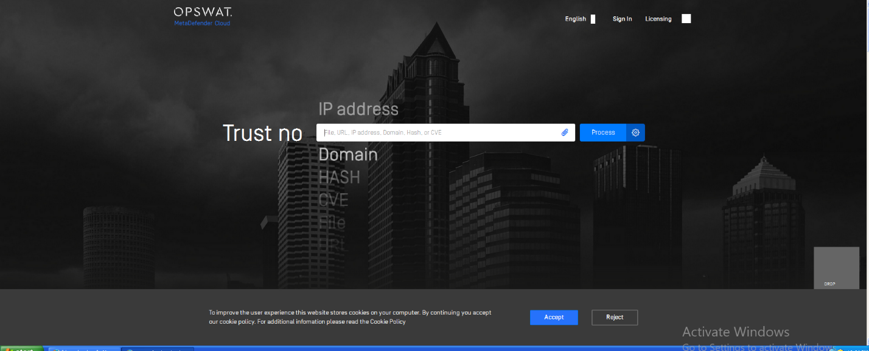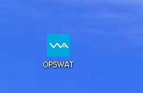Can be provided as a tool or web-based like VirusTotal

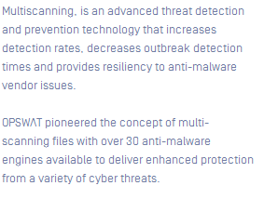

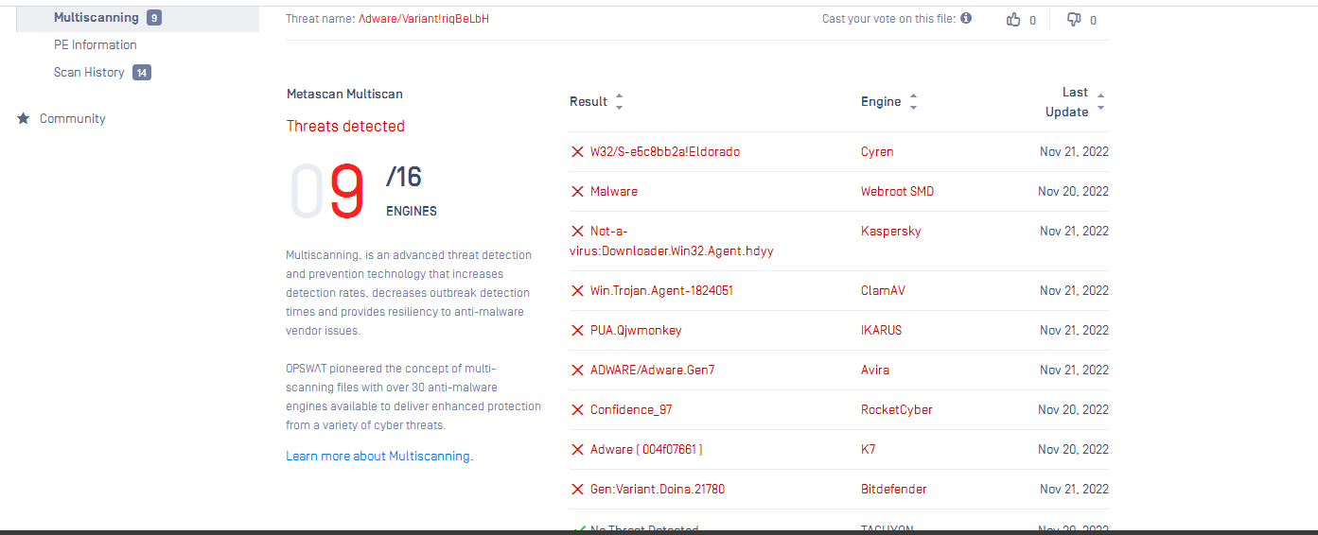



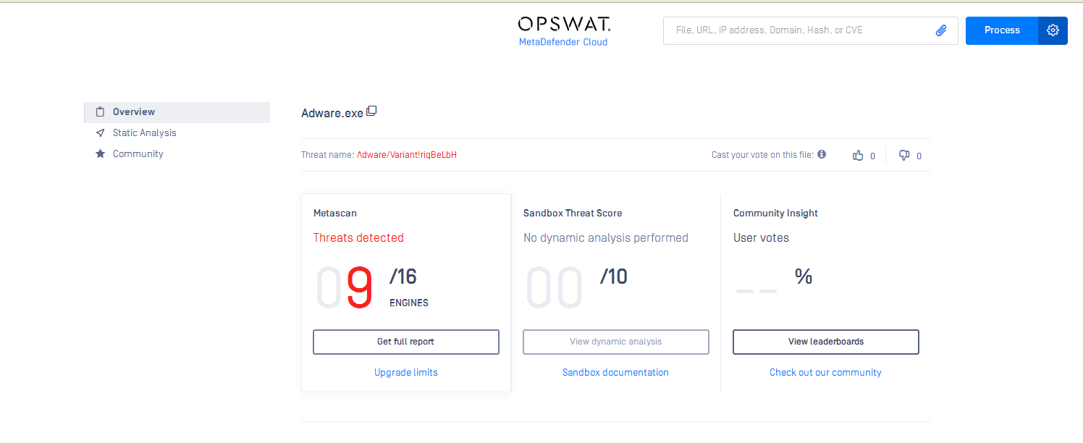

All of the above tools provide the ability to get the hash of a malware that can be uploaded to

Tools such as VirusTotal and Metadefender to provide a report about engines that marked the

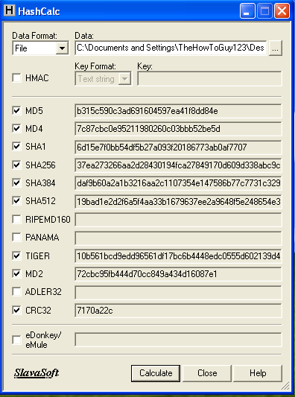File as suspected and the ones that don’t.

**c)HashCalc:**

**D)MD5ddep:**

It’s a command line interface that provides the hash of specific file specified in the path below.

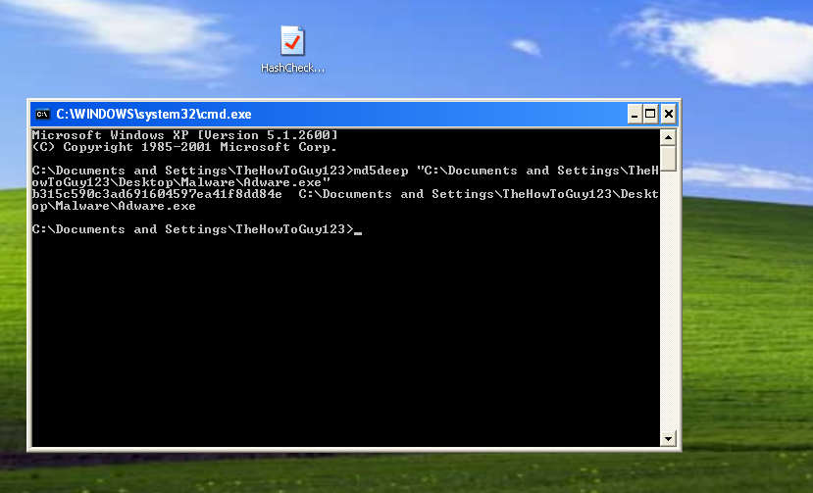

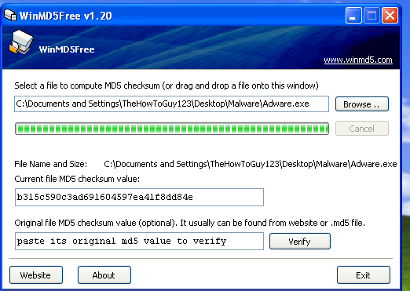

**E) winMD5FREE:**

**It allows to match the**

**Calculated hash with**

**Entered one.**

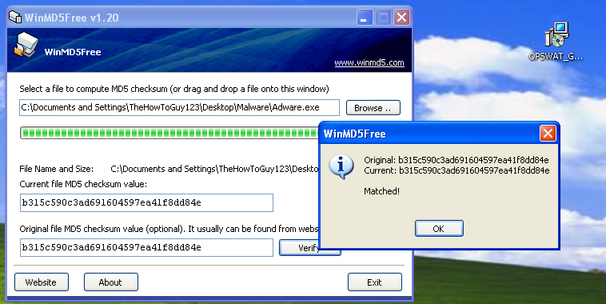

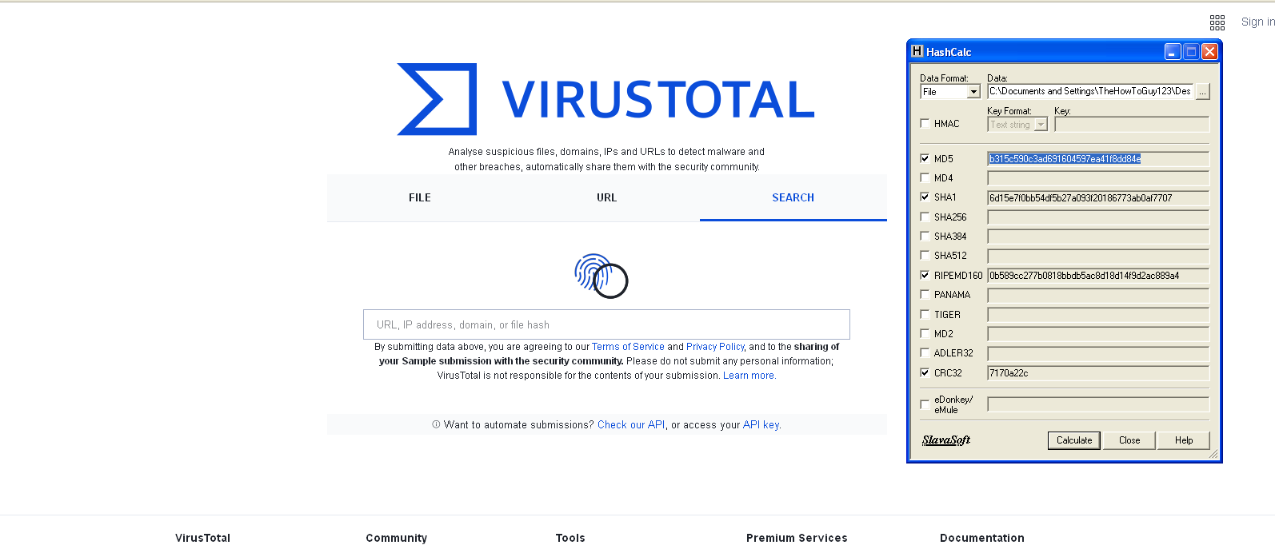

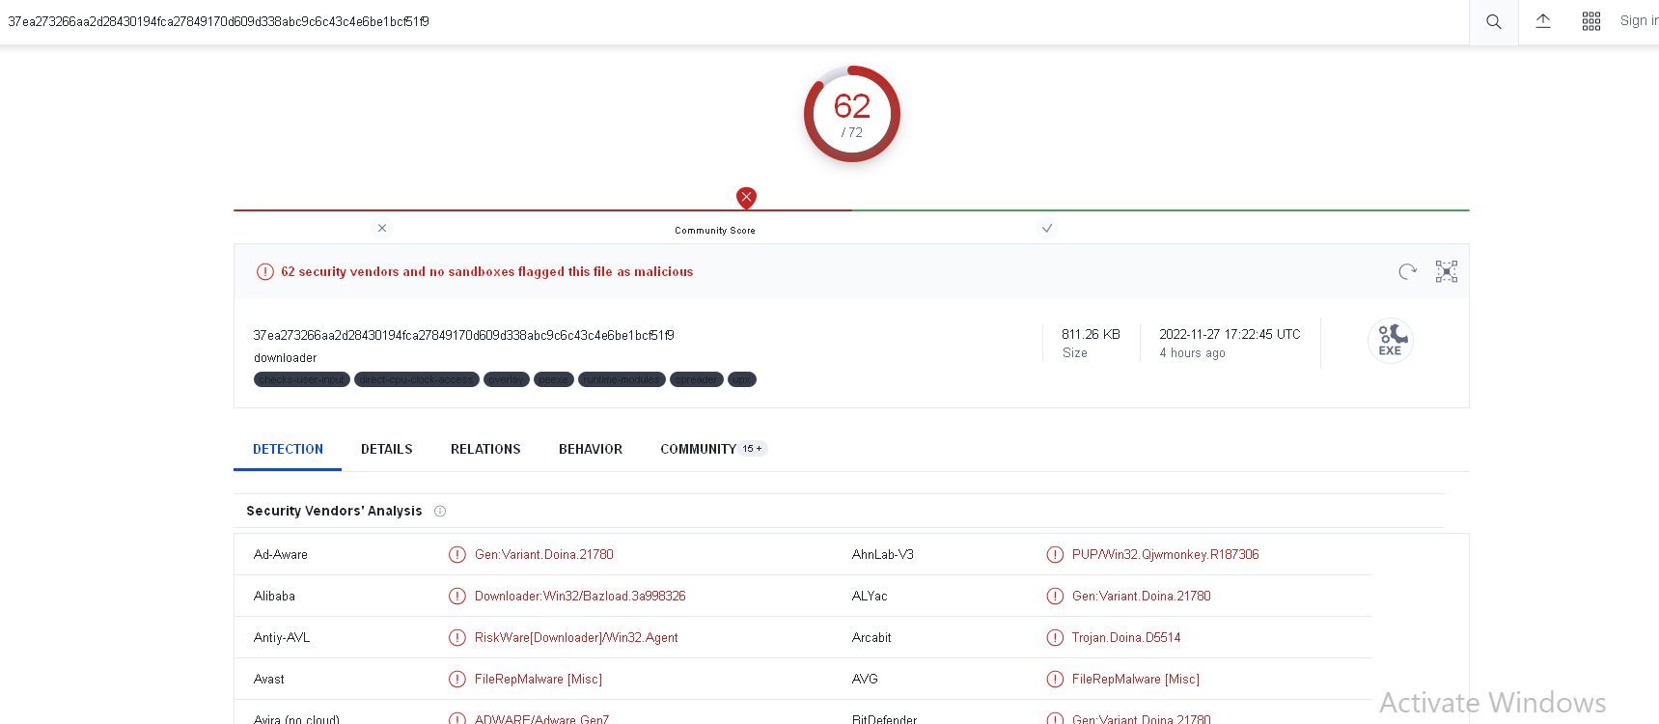

**F) Strings/strings64/strings64a:**

One very useful technique in malware analysis is string analysis. In many cases using strings obtained from the binary file we can reason about some of the features of the malicious code. For example, if we find a list of SMTP servers, we might suppose that malware might be sending spam messages.

**The alternative for those since they cannot work with Win32 XP is type which is also a command line interface.**

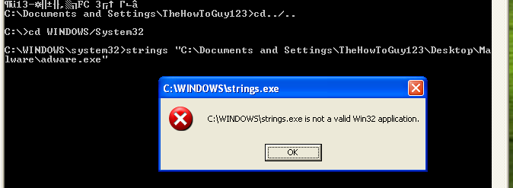

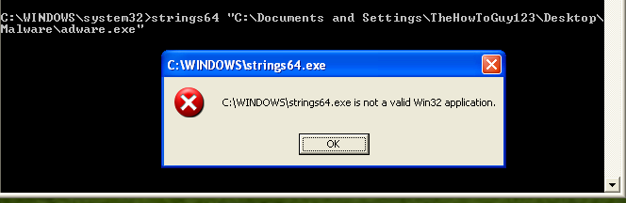

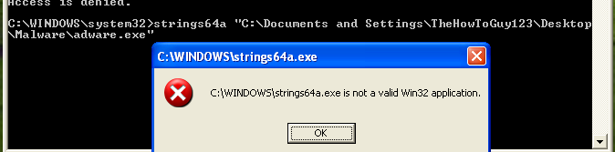

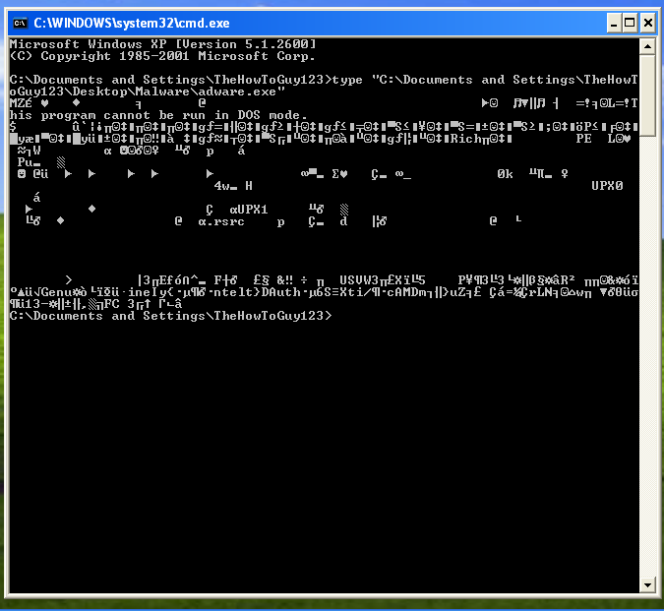

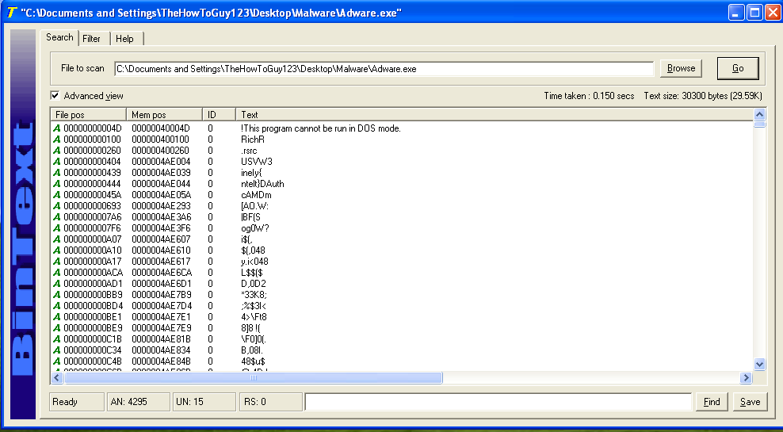**G) BinText:** BinText is a file text scanner / extractor that helps find character strings buried in binary files. The program can extract text from any kind of file and display plain ASCII text, Unicode (double byte ANSI) text, as well as Resource strings.

***Many things can be gathered from strings using Bintext:***

**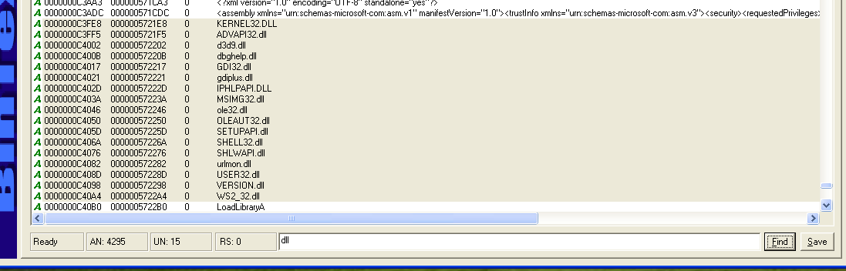*A-*** *Here we can see a fragment of the DLL names6 and imported functions list. It is good to compare such a list with names found in import table in PE file (Portable Executable). Sometimes malware dynamically loads certain libraries and functions making them not listed in the PE file import table.*

**B-** Typical HTTP headers suggest that malware is likely using HTTP or HTTPs communication – to contact Command & Control server or for some other purposes and since the malware adware connects to the internet in the attempt of download other malwares.

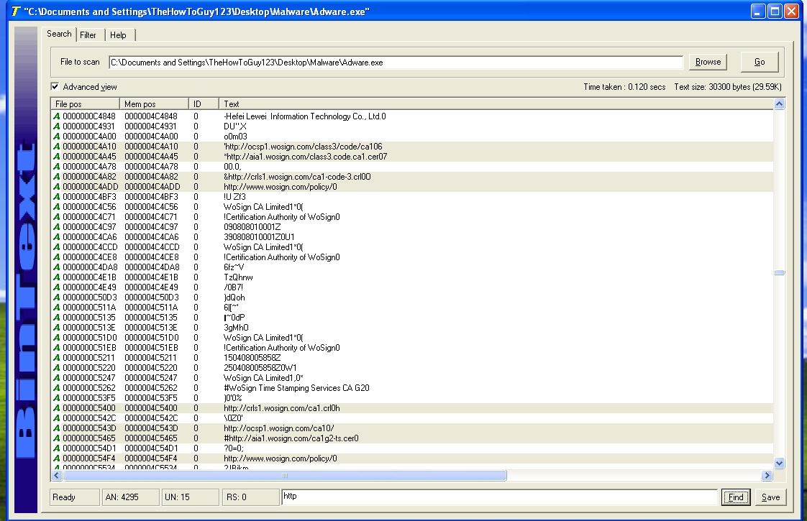

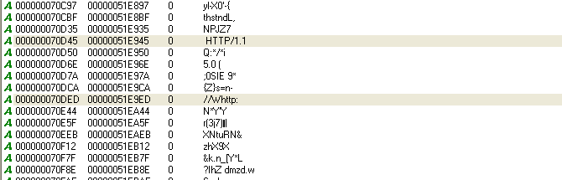

**H) PEid: is a tool that can be used with obfuscated malwares to recover the tool that was used**

**For obfuscation in order to unpack the malware for better analysis.**

**Note:**

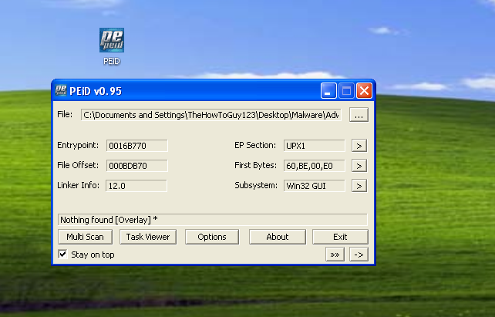**Nothing found delay**

**Means that the program is not**

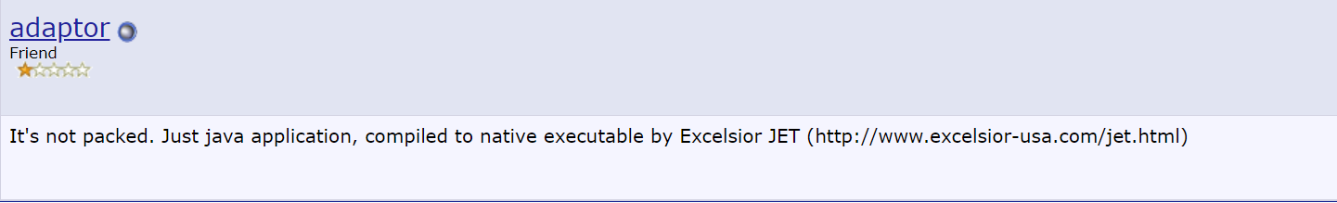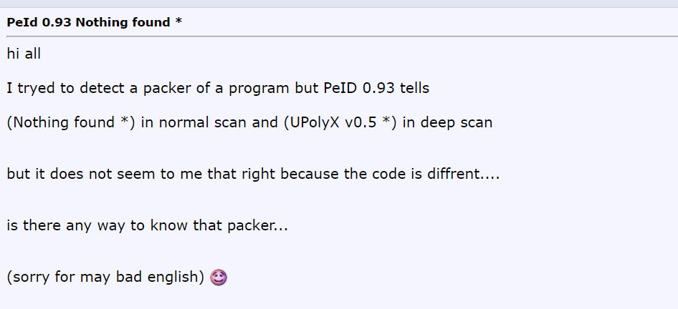**Obfuscated.**

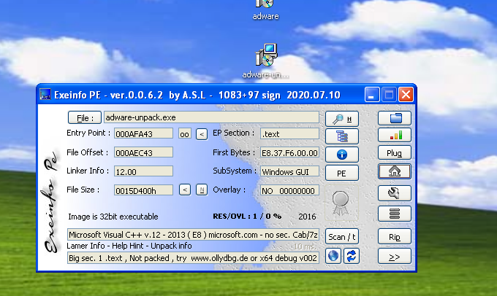

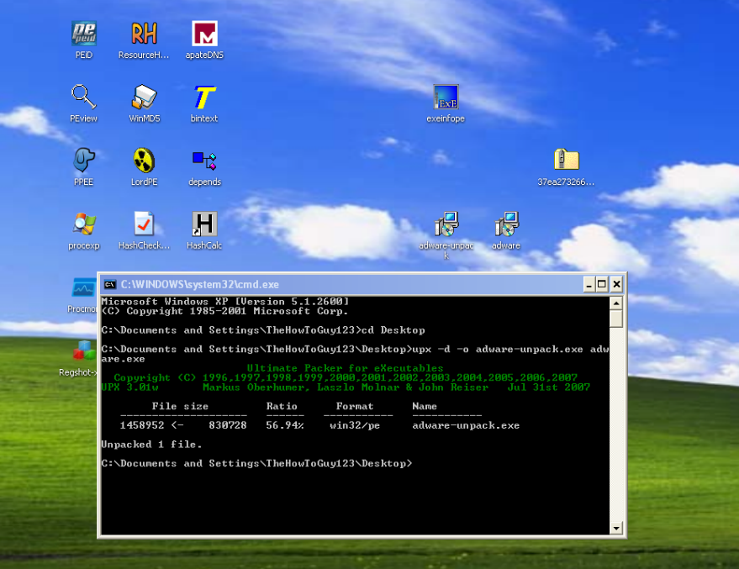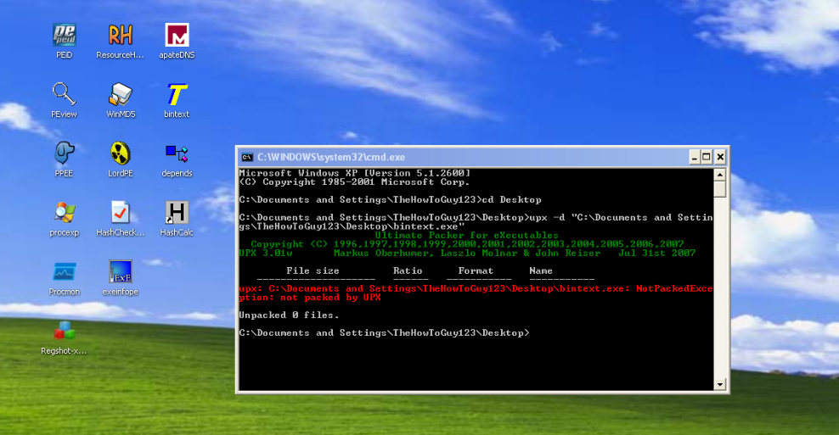

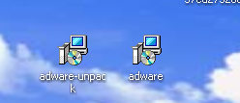-The malware compression can be checked by the upx tool-

As viewed from the screenshots above firstly, by using the PEID in order to see if the malware is compressed or not it gives nothing found (Overlay) after searching it shows that it is a java compilation. Then by using the UPX-Installed by the UPX shell it was successfully uncompressed and tis was ensured by using Exeinfo PE (The step of checking the packing it was done by using the LordPE that shows in the headers UPX0 and UPX1 which they are suspected headers name).

**I)LordPE:**

*It provides the PE header information such as sections like:*

***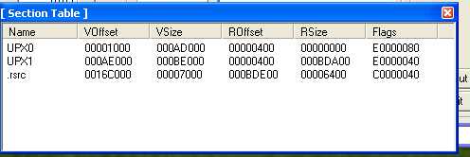****.text instructions for the CPU to execute*

*. rdata imports & exports*

*.data global data.*

*rsrc – strings, icons, images, menus*

***This shows the section table for the malware and there is***

***Suspected names like UPX0 and UPX1 this is the reason that we used upx to check the if the file is compressed or not***

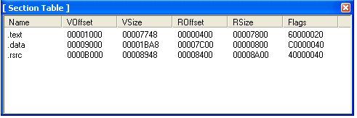***This shows the section table for the notepad within the***

***Normal section names***

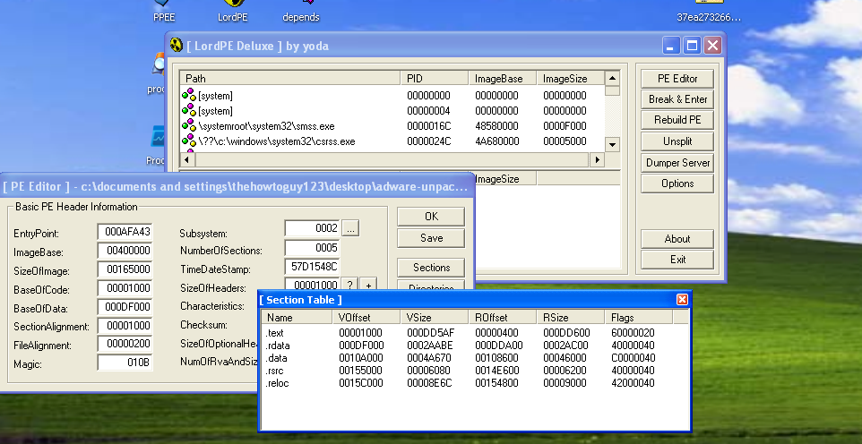

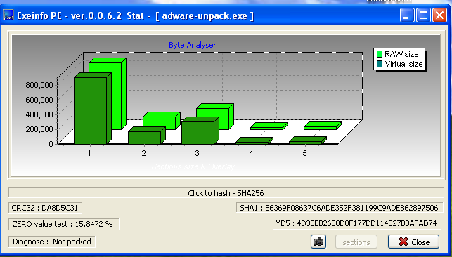**J) Exeinfo PE:** is a program thatlet us verify the exe files and check out all their properties

*A-It can provide information about whether the malware is diagnosed (Packed or not).*

*B-It can provide the headers of PE file format, the size and their status.*

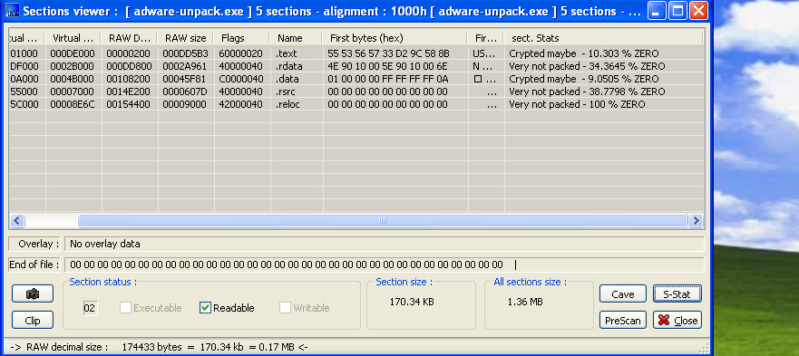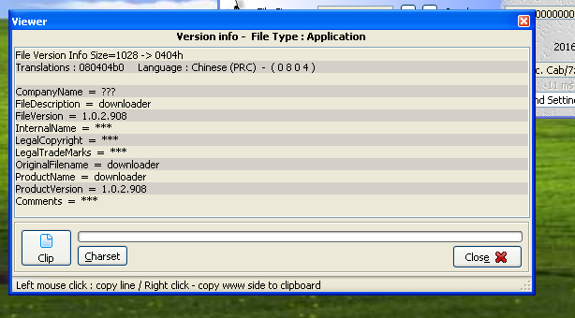 *C-Information related the malware whether its compressed or not.*

**J) PEview:** *Windows executable file (PE) headers contain information about the executable file and how it should be executed. PE headers tell the operating system how it should load an executable file, what libraries are needed, where the beginning of the main routine code (code entry point) is or even when the binary file was created.*

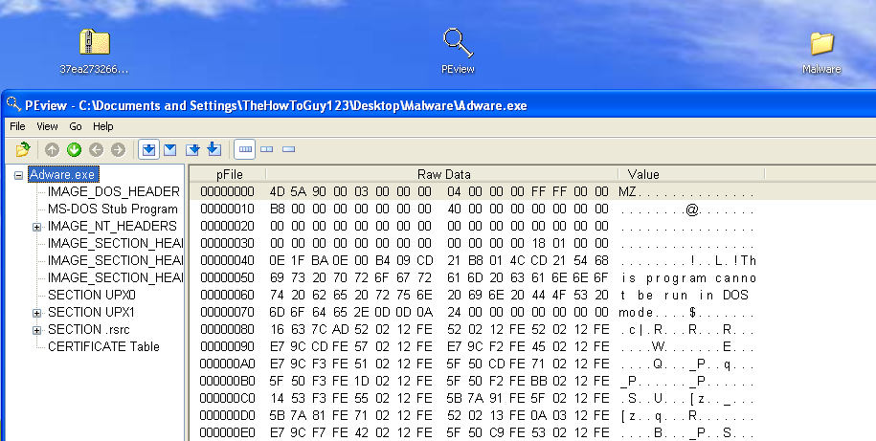

**Gathered data from PEview:**

1. 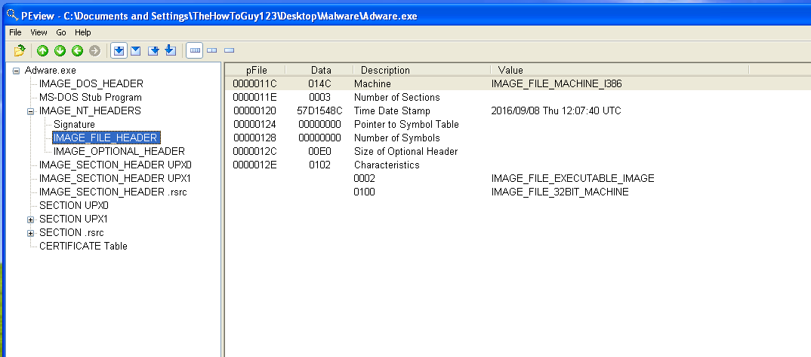TimeDateStamp: Open the sample in the PEview tool and switch to IMAGE_FILE_HEADER. One of the interesting fields in this section is Time Date Stamp which tells when the binary executable was likely linked. This field might have been intentionally tampered with but it doesn’t happen often.



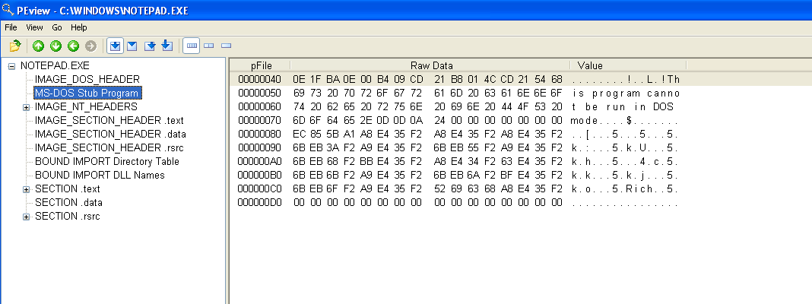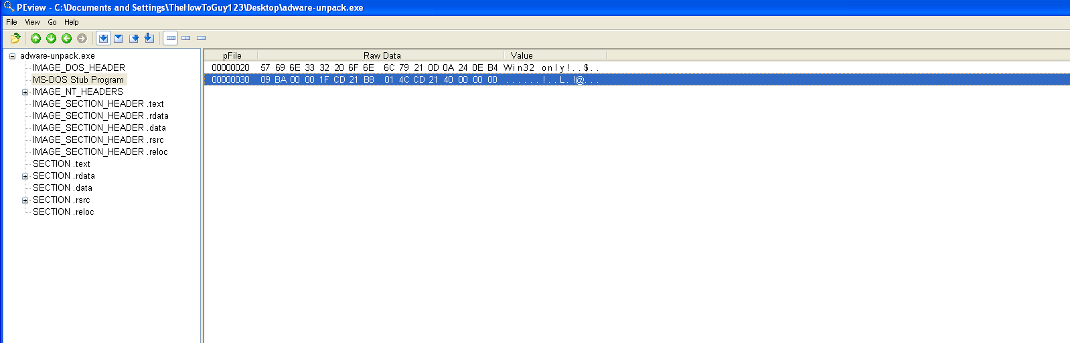**B-**In the normal program the MS-DOS stub includes a message that this program cannot be run in DOS but the malware lacks this message



K) ***File Alyzer*:** is file analysis tool, initially created as our internal helper in updating our detection database.

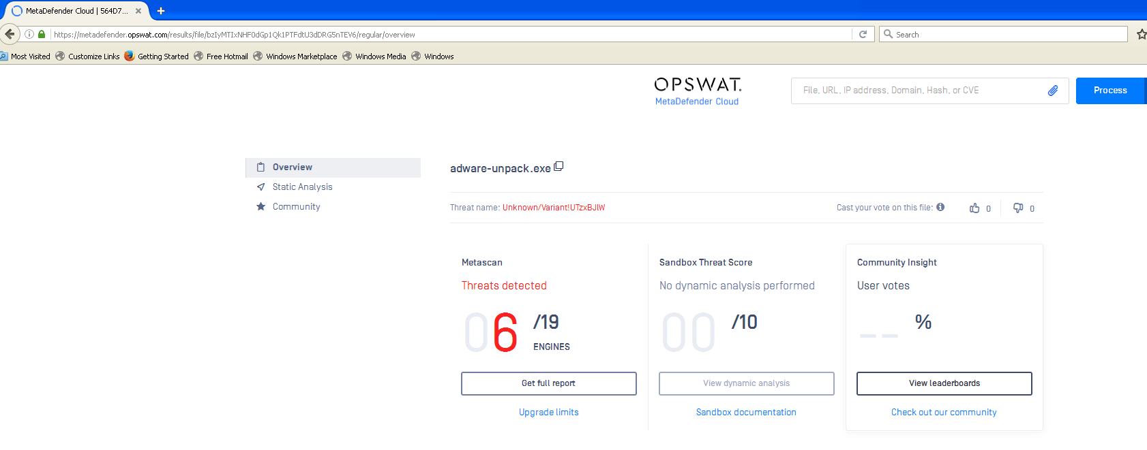 1-It includes CRC (cyclic redundancy code) 🡪 mainly used for the error detection and MD5 that can be used to see if others marked the infected code by VirusTotal.

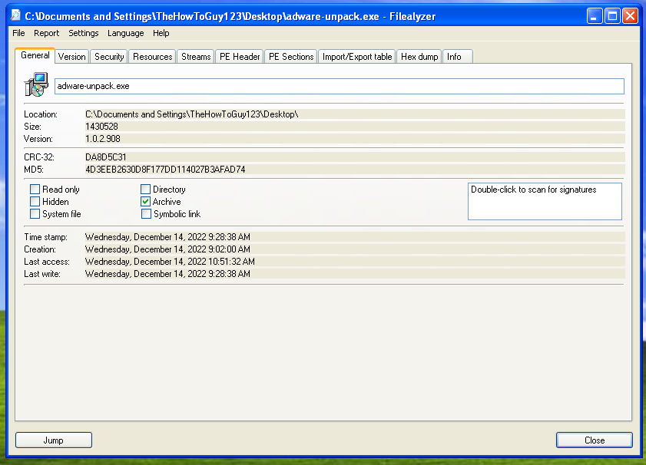



2- it can provide additional information about the headers and sections as well as the resource hacker

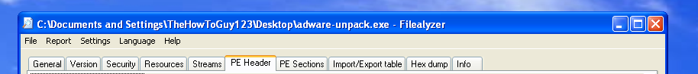

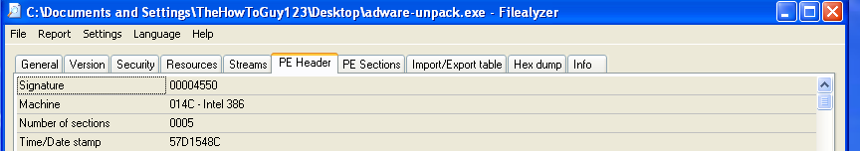

Signature have to start with 4D5A

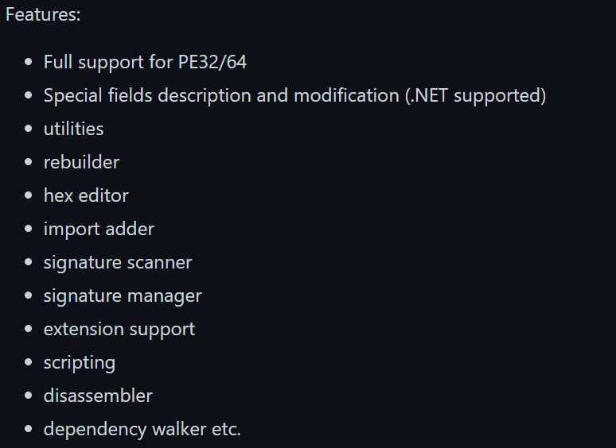L) **CFF Explorer: A freeware suite of tools including a PE editor called CFF Explorer and a process Viewer.**

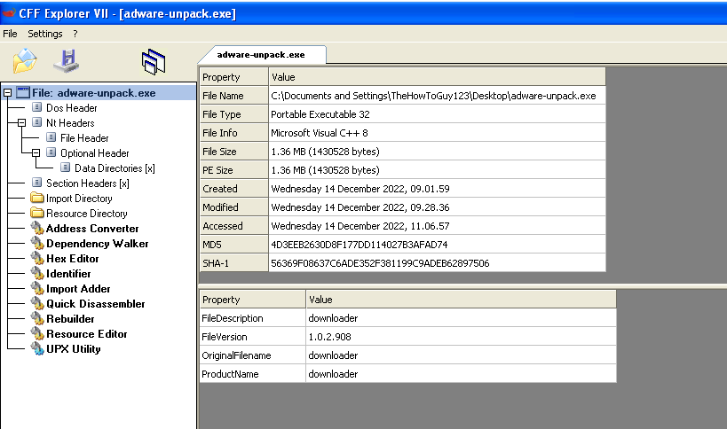

1-provide a repot about engines that mark the file as suspicious.



2-Less number of DLLs

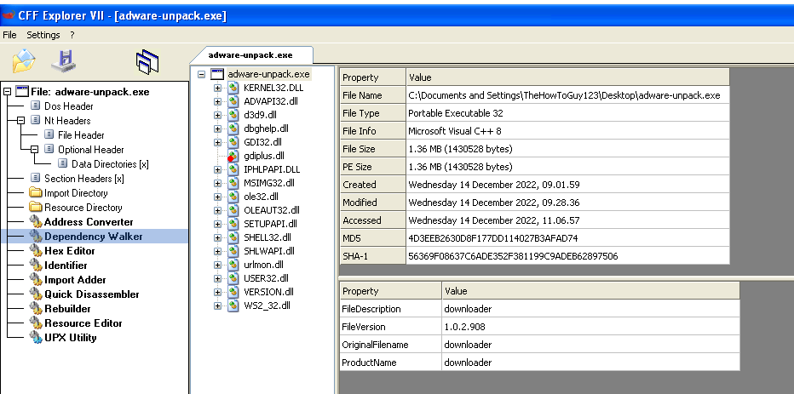

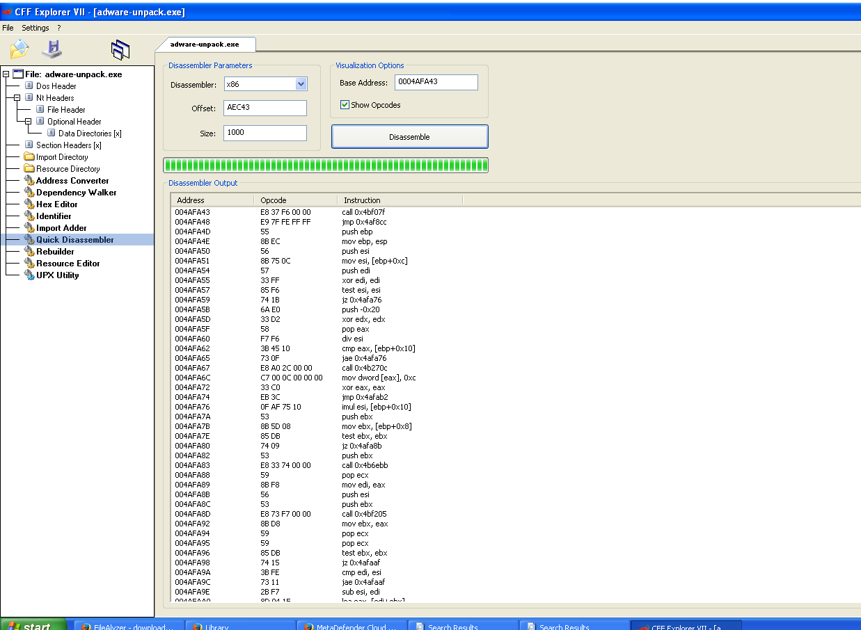

3-Provide a disassembler

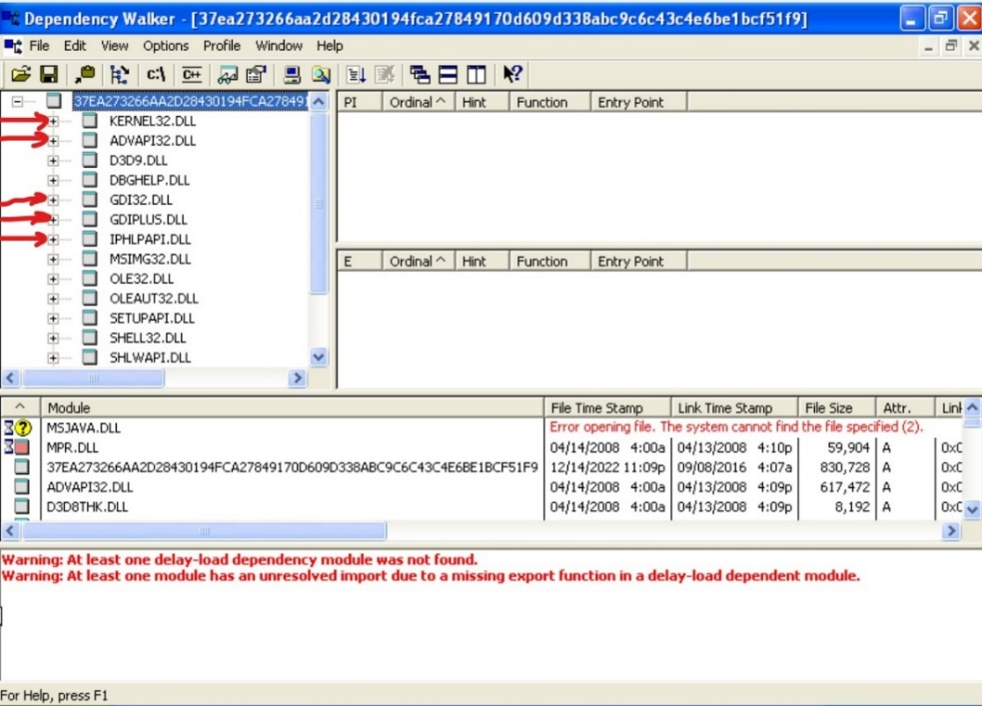M) **Dependency walker:**

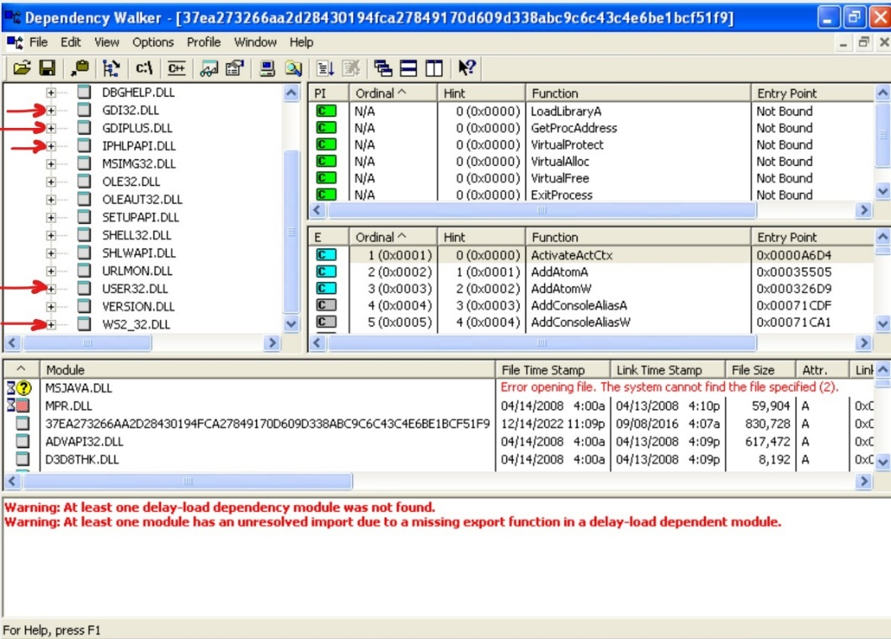As we can see in the screenshots, there are many suspicious dll files, such as kernel32.dll that gives the exe file access to manipulate and change files and memory. Also, advapi32.dll gives ability to change the registries and add services. Gdi32.dll and gdiplus.dll would allow the malware the ability to show and manipulate graphical windows and entities. Iphlpapi.dll and ws2_32.dll grant the malware access to the internet using windows IP helpers and sockets.

As well as the number of DLLS much less than the normal legitimate program.

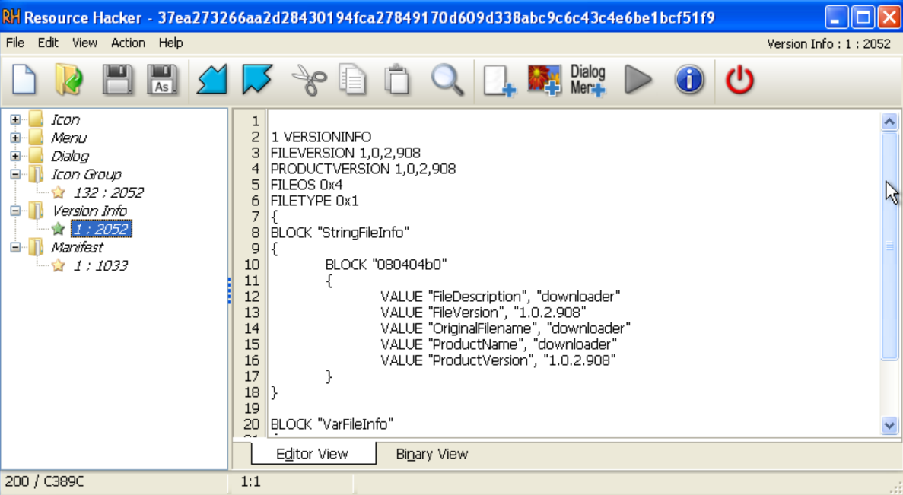N) **Resource hacker:**

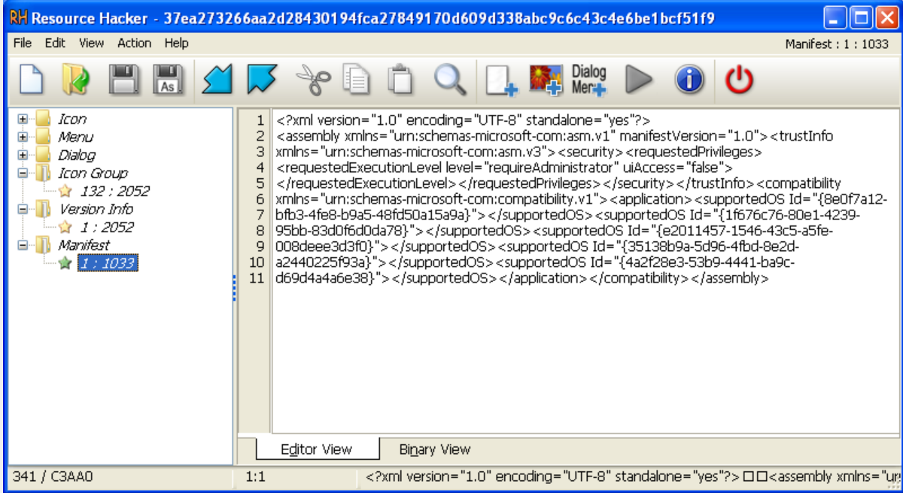From the screenshots above we see that the version info section is not so descriptive, the file description, filename and product name are all ”downloader” which would be very suspicious if it was a normal exe file. Also, the manifest section that describes the file’s dependencies has to provide more details in a more organized way.

5-Basic Dynamic Tools:

**1-Free Sandbox.**

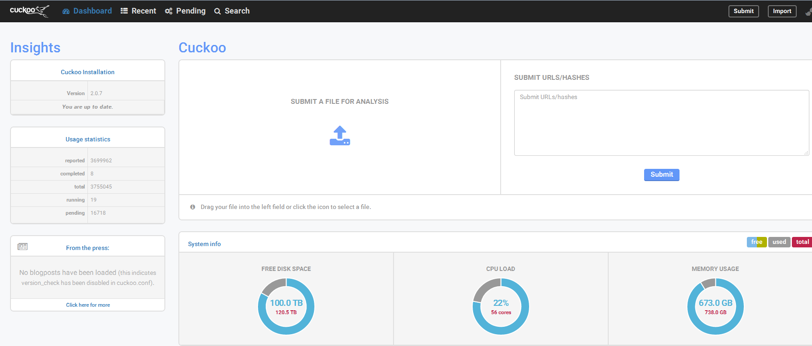**Cuckoo Sandbox**

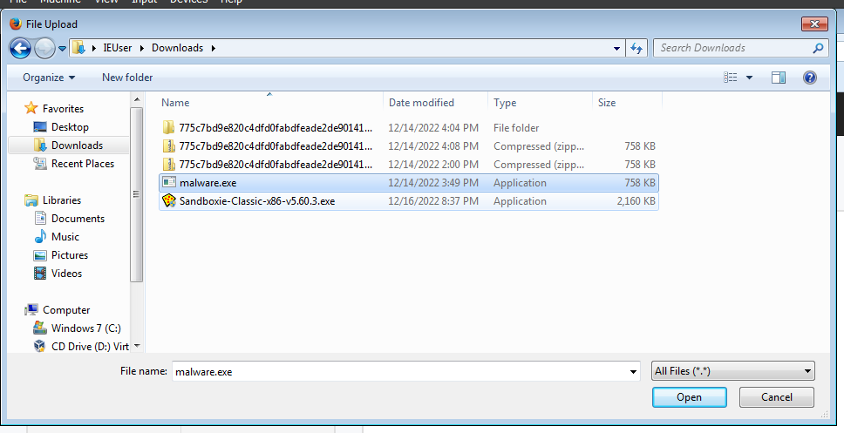**Opening malware**

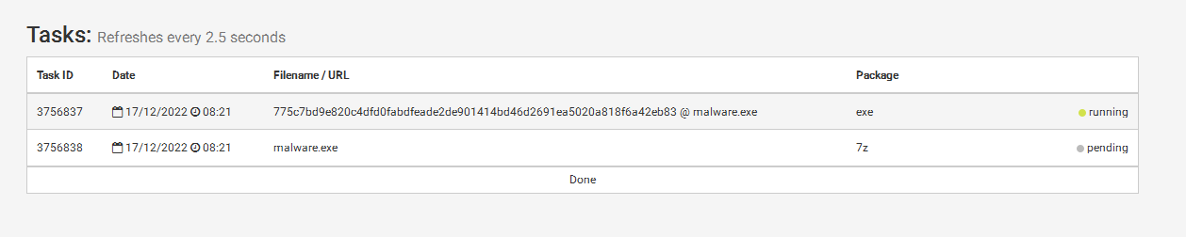**Malware under analysis**

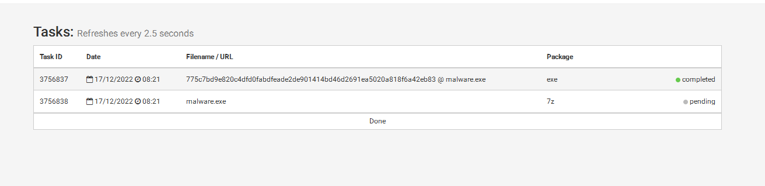**Analyzing have finished**

**Report**

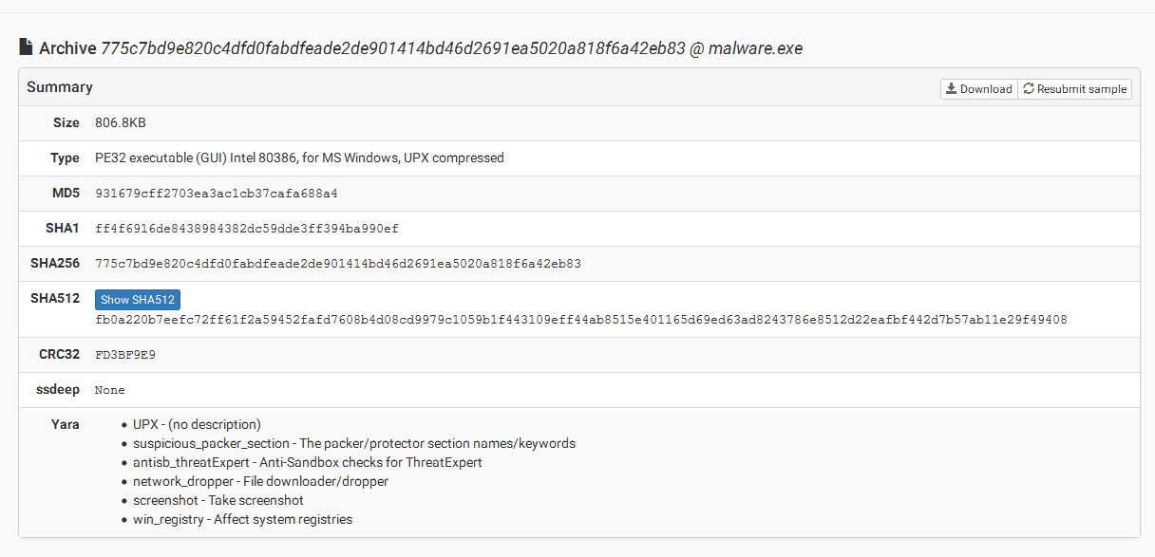**🡺** attachment’s identity

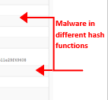

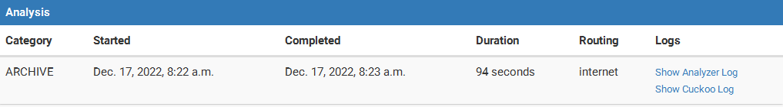

**Time taken to analyze the whole malware**

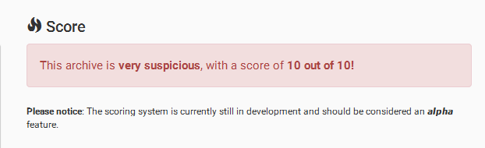**File rating (it is very suspicious)**

**Screen shots**

**-**Screenshots of the sandbox environment during the analysis process, i.e. Visual of how the sandbox was affected.

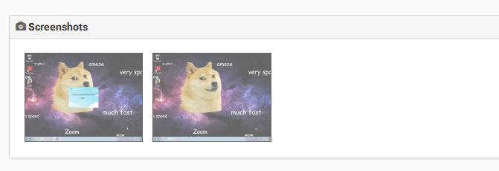



**Signatures**

**-**Signatures are the significant aspects that lead to the scan result. e.g., Network connections, downloads, creating files, modifying system files, etc.

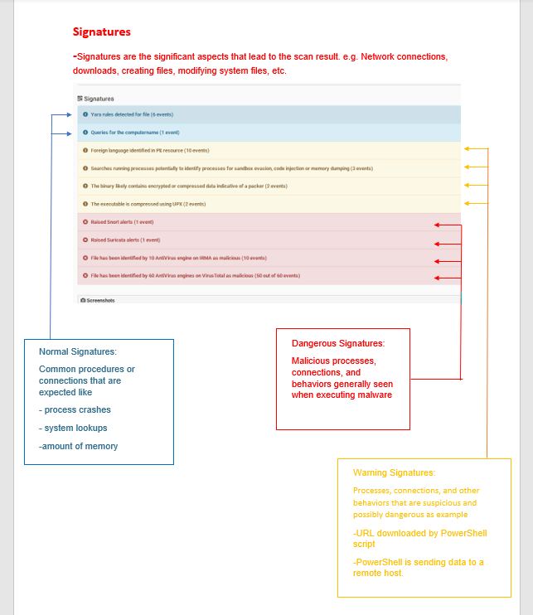

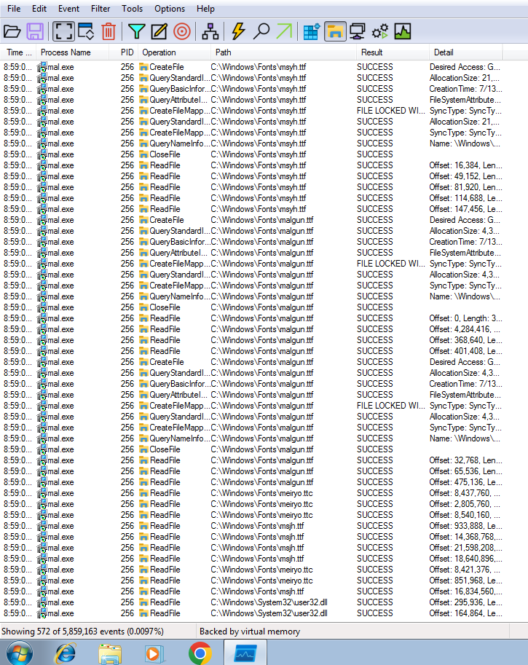

**2-ProcMon.**

As shown above in only a few seconds of the malware being run it has done more than 500 processes regarding the file system, and the processes varies since some them requests to open a file, read a file, create a file and much more processes.

* Here is a sample of the network activity:

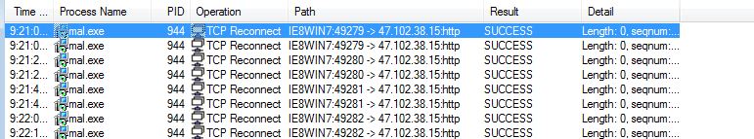

As show in the image the malware has done several TCP connections to the same IP address “47.102.38.15” which is probably the C&C (command and control) server, and as it appears it has been already scanned by other malware analysis tools and they assure that it is related to some kind of malware and it is located in China.

* Here is a sample of the registry activity:

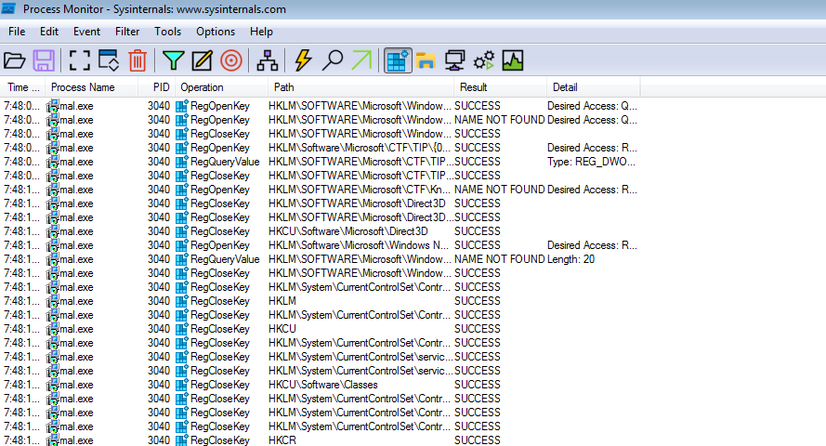

The malware opens up several registries desiring read access or other privileges on them, the registries include control and services registries.

**3-Process Explorer.**

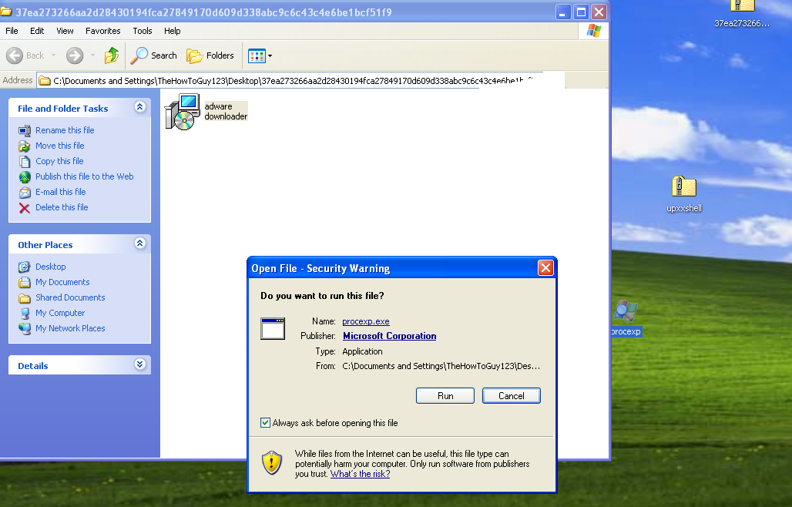

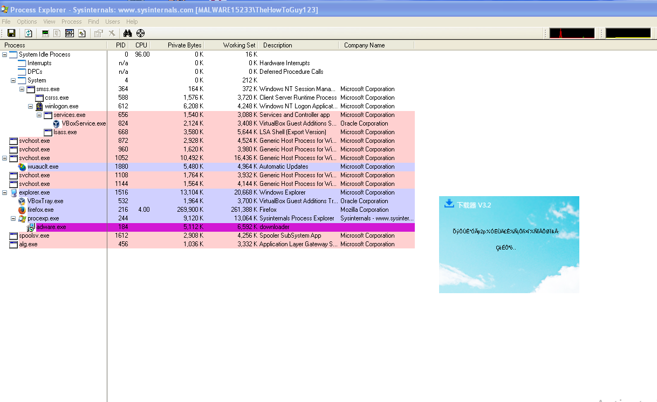

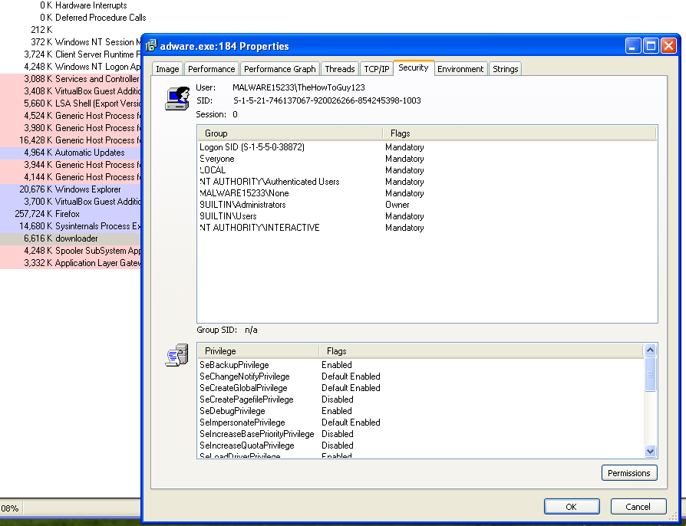

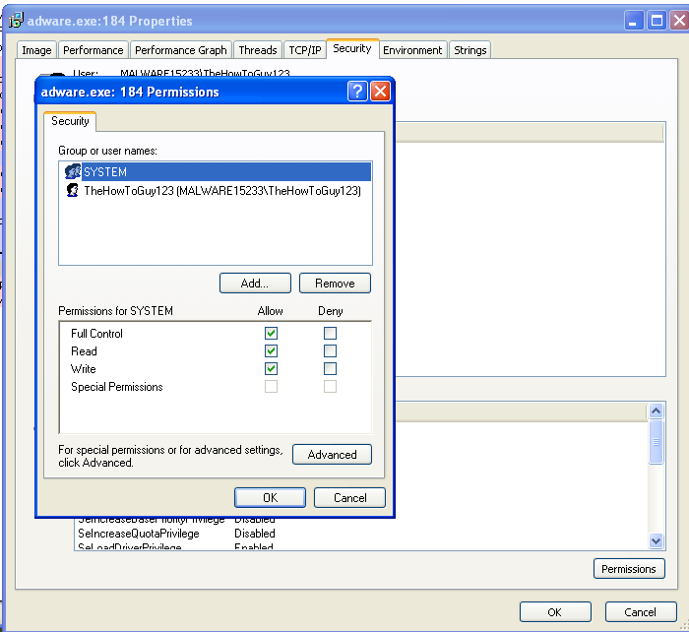**As shown in the screen above we can see that process explorer allow us to see the privileges that the downloader have SetBackupPrivilege 🡪 Back up and restore all files on a computer, regardless of the permissions that protect those files also Backup permission can log on to and shut down the computer. And many other privileges.**

**We can see whether is able to RWX and it does the malware able to read, write and execute.**

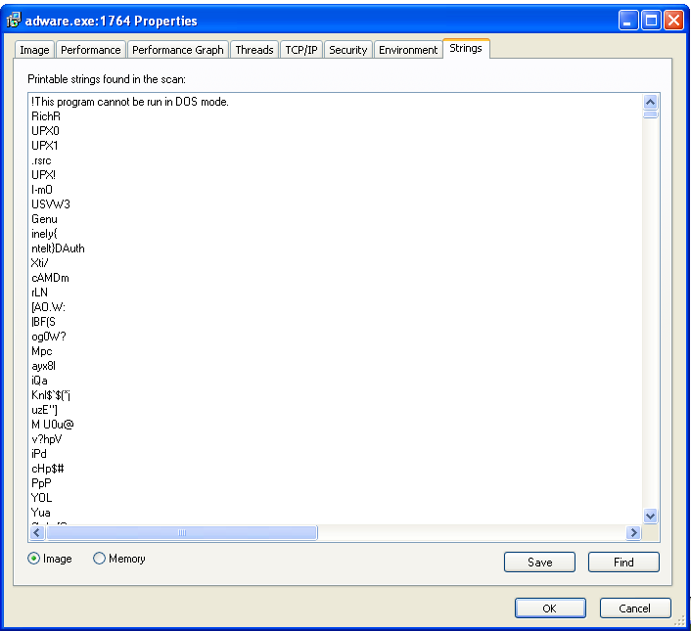

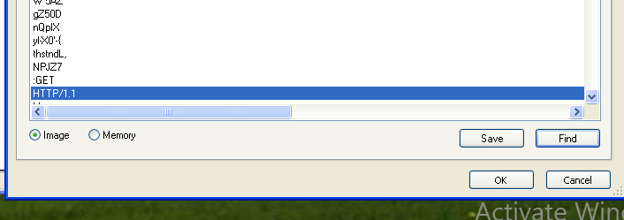

**It allows us to see the strings such as http which means that the malware accessing the web and might try to install additional malwares to infect the machine.**

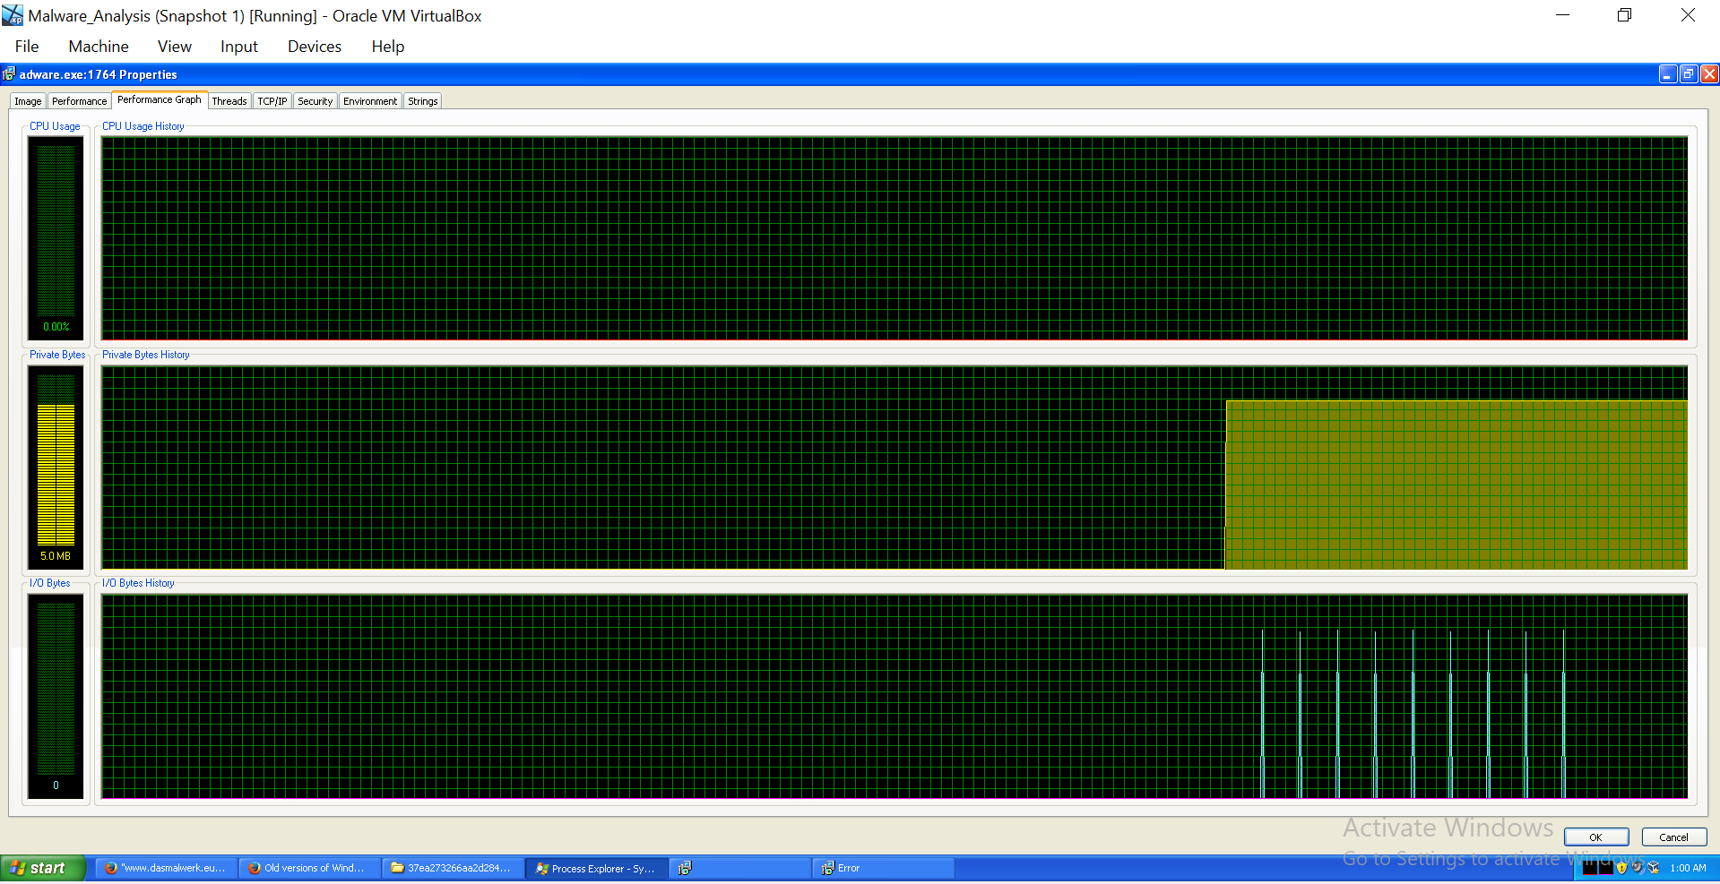

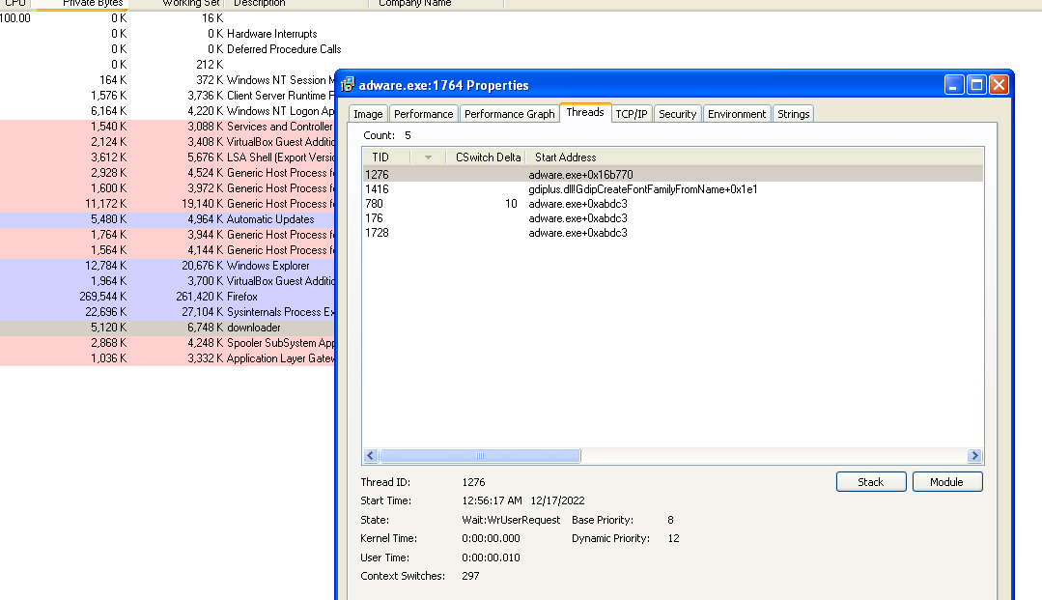

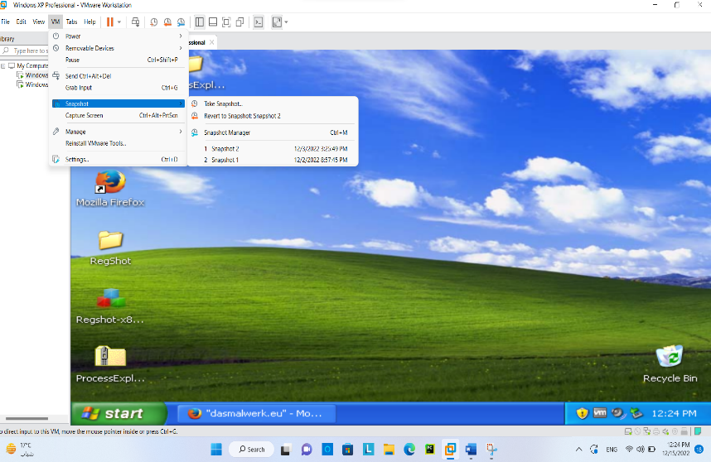**4-RegShot.**

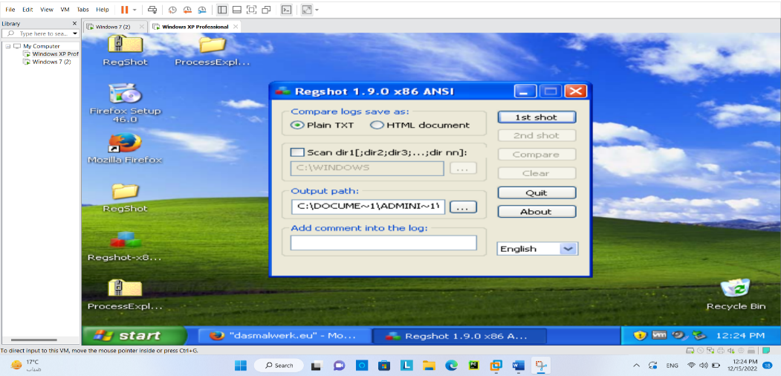**took a snapshot & then started the first shot.**

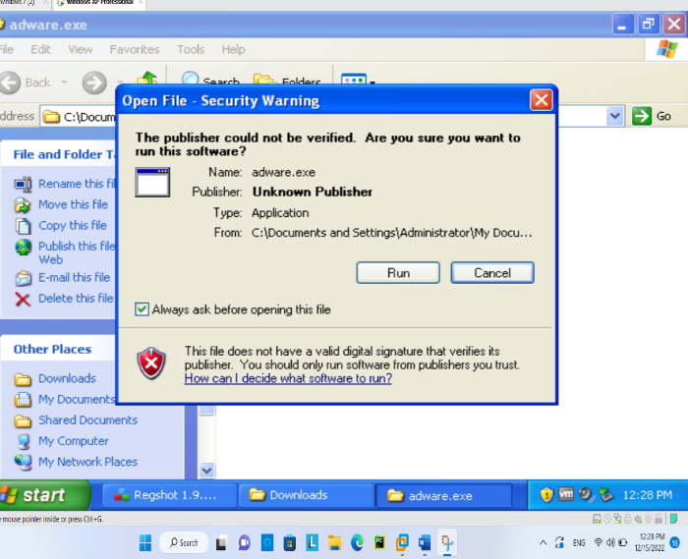

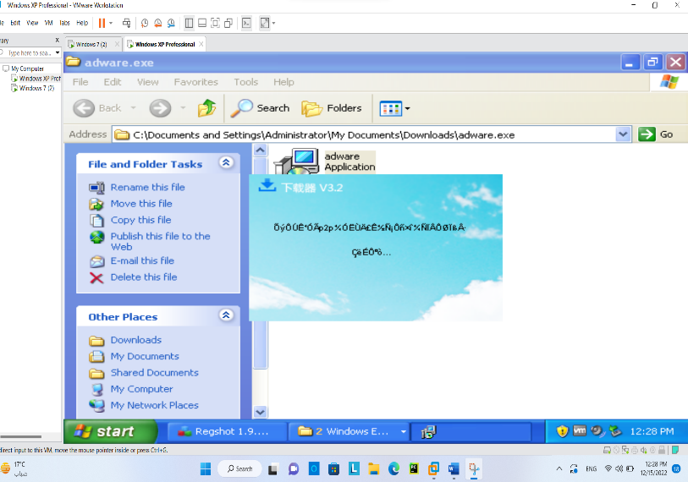

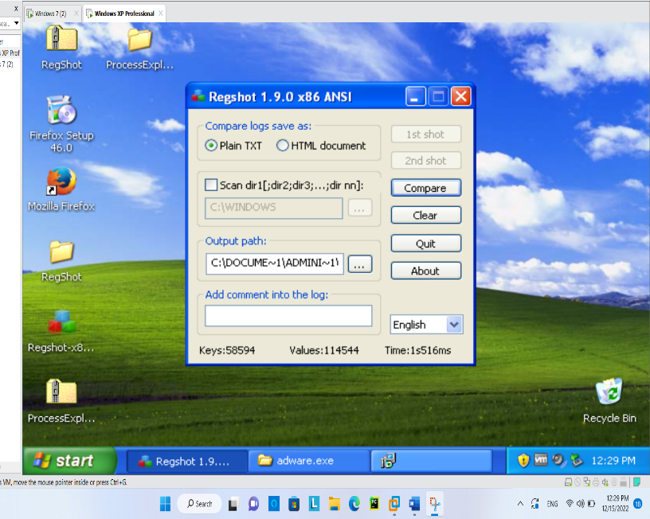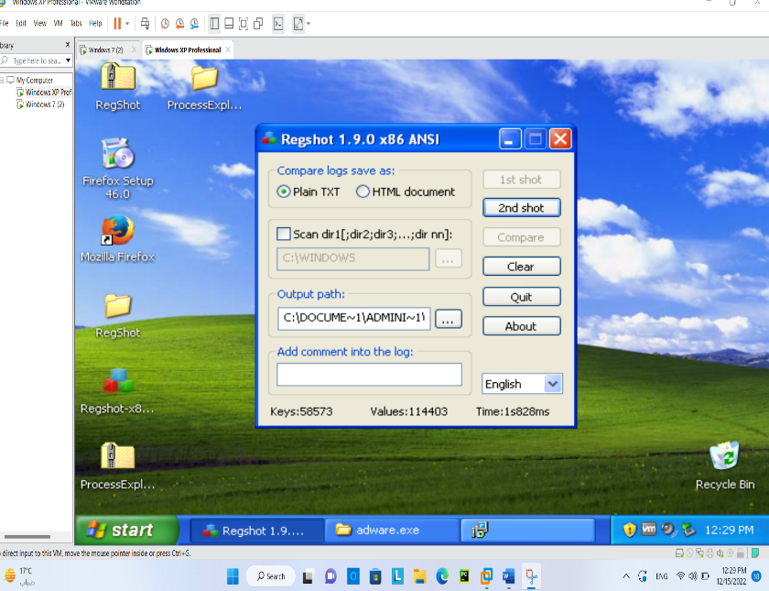

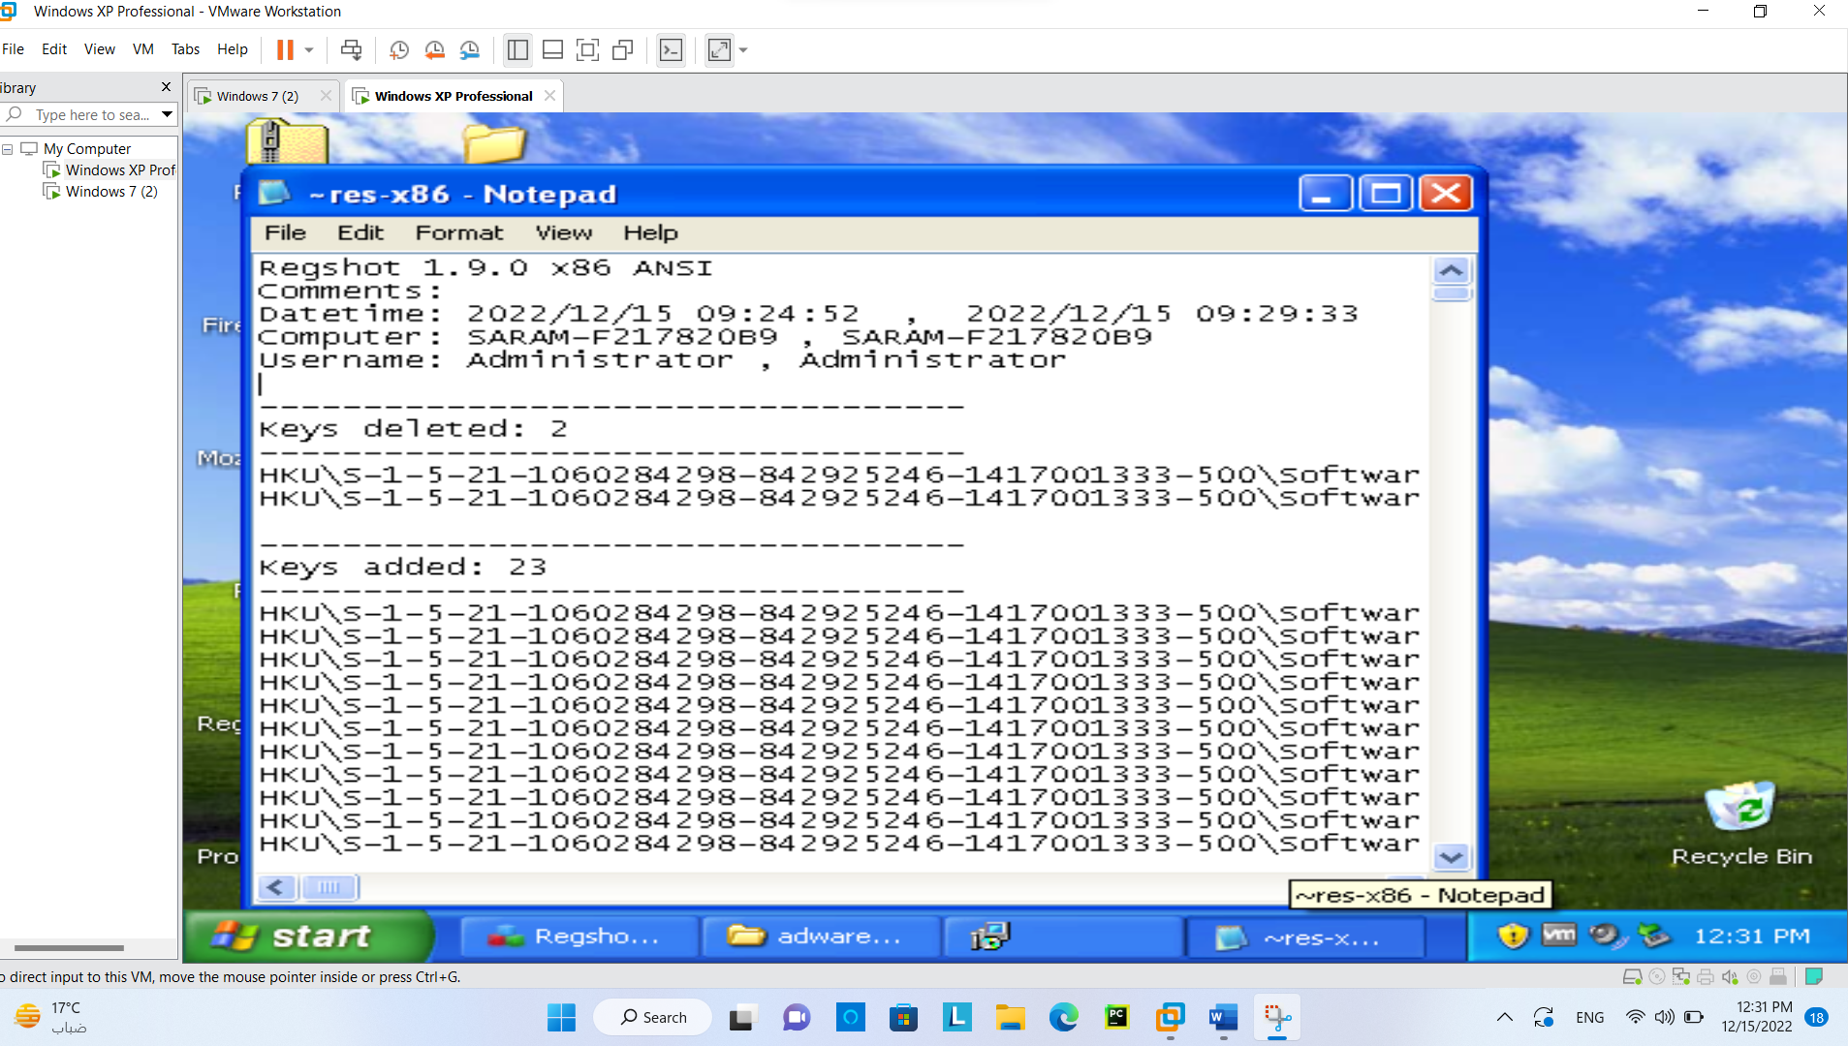

The Analysis:

Firstly, we need to know that the registry is a hierarchical database that contains data that is critical for the operation of Windows and the applications and services that run on Windows. The data is structured in a tree format. Each node in the tree is called a key. Each key can contain both subkeys and data entries called values. Another important thing we need to know is that the registry contains two basic elements: keys and values. Registry keys are container objects similar to folders. Registry values are non-container objects similar to files.



1- This malware leaded to delete 2 keys which are responsible for changing the cache limit to the size you want. 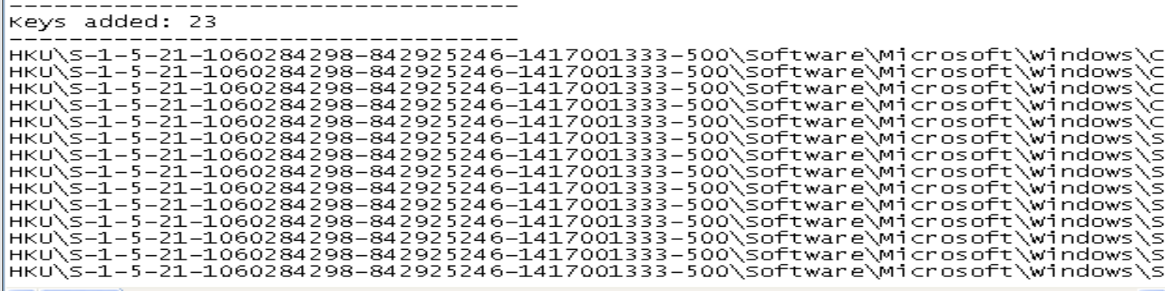

2- IT ALSO ADDED 23 KEYS



* This is a key that is responsible for managing the recycle bin.



* Also added 2 keys: 1st one for recently accessed files (in hex) , 2nd one for cache limit

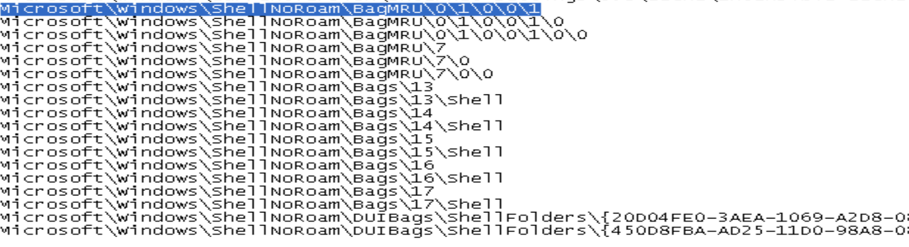

* 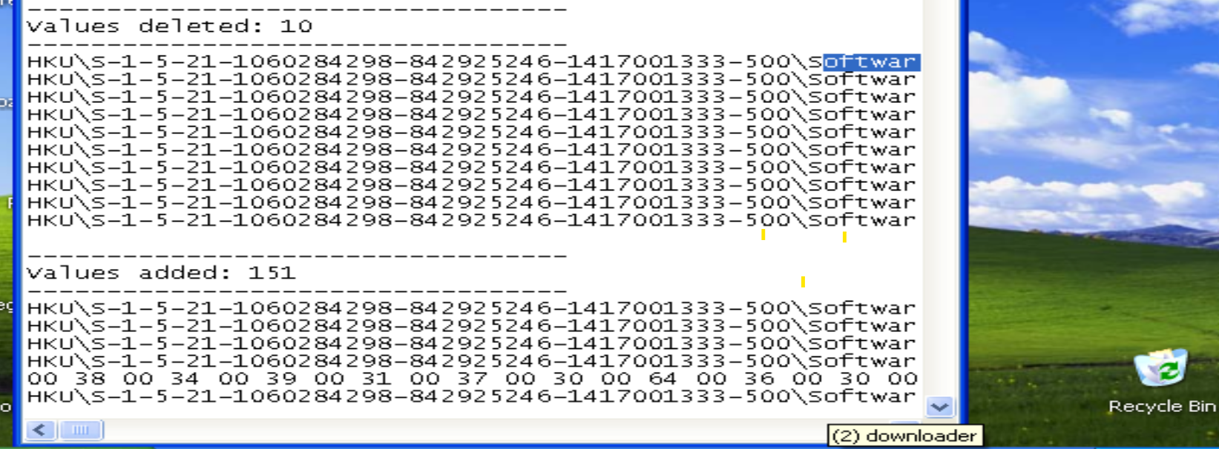Added ShelNoRoam keys that are responsible for the ShellBag information for the Desktop, ZIP files, remote folders, local folders, Windows special folders and virtual folders.

3- It deleted 10 values and added 151.

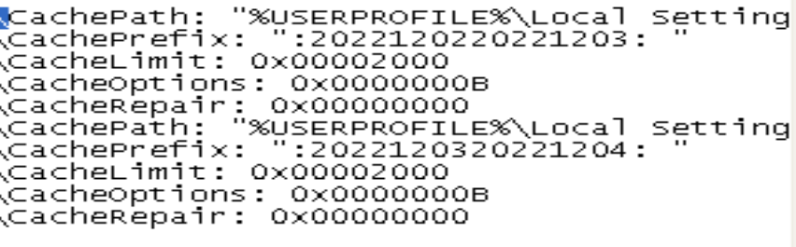

* It added values that controls the cache limit, cache prefix, cache options and so on.

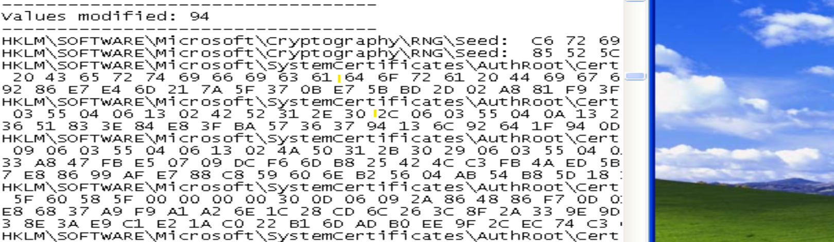

4-It also modified 94 values



* This value is designed to point to DLL-based driver for hardware-based encryption accelerator. Such a DLL has access to crypto keys stored on the NT machine, and thus, to Trojan DLL could gain access to the crypto keys. AND IT MODIFIED IT.



* It changed the root certificate many times.

